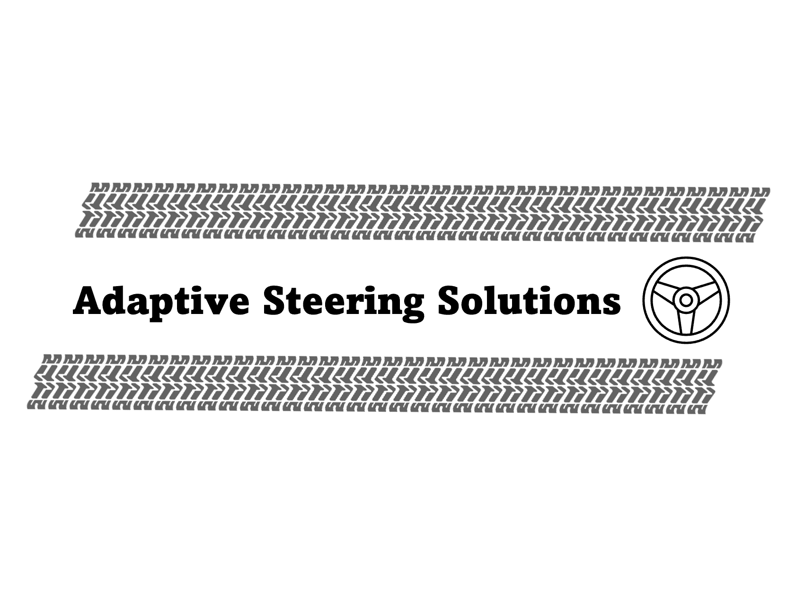

Four-Wheel Steering for FSAE Racecar

A report submitted to the University of Arlington’s FSAE team, UTA Racing.

Written By: Osama Almasri, Sarbagnya Bhattaria, Tayden Carter, George Kallam, and Samatar Samatar

August 8th, 2025

**Abstract**

This report is intended to present the design of Adaptive Steering Solutions approach to electronic four-wheel steering on an FSAE car, specifically F16. The current FSAE rulebook allows 6 degrees of rear wheel steering, and our system is designed to accomplish this using only counter steering. The rear steering geometry and kinematics had to be redesigned to allow for optimized rear wheel steering given the allowable number of degrees. This required design changes to the cars’ existing components, including new uprights, steering linkages, bell cranks, and mounting tabs that facilitate the proper connection of components. For system controls, we developed a PD strategy using steering position sensors that allow proper output and direction. This is well suited to adapt to the nonlinear nature of the system and allows rear steering to vary based on steering wheel angle position.

**Sponsor / Faculty Advisor:**

Dr. Bob Woods - [woods@uta.edu](mailto:woods@uta.edu)

**Team Member Contact Information**

|  |  |  |
| --- | --- | --- |
| **Member** | **Email** | **Phone** |
| Osama Almasri* | osama.almasri@mavs.uta.edu | (682) 201 – 6728 |
| Sarbagnya Bhattaria | smb9593@mavs.uta.edu | (817) 542 – 7531 |
| Tayden Carter | [tjc4957@mavs.uta.edu](mailto:tjc4957@mavs.uta.edu) | (817) 889 – 6020 |
| George Kallam | george.kallam@mavs.uta.edu | (817) 229 – 6590 |
| Samatar Samatar | samatar.samatar@mavs.uta.edu | (817) 513 – 1601 |

**Client Information**

|  |  |  |
| --- | --- | --- |
| **Client** | **Email** | **Phone** |
| UTA FSAE | [woods@uta.edu](mailto:woods@uta.edu) | (817) 996 - 0707 |

**Introduction**

Four-wheel steering allows for direct control of all wheels in the vehicle. Most common vehicles today operate in a two-wheel steering system where the front wheels control the direction of the vehicle. The four-wheel steering system can allow for the functionality of two distinct operational modes: parallel steering and counter steering. In parallel steering, all four wheels turn in the same direction; this is done at high speeds to leverage the benefits of enhanced vehicle responsiveness and handling. The other mode of four-wheel steering is counter steer where the rear wheels turn in the opposite direction of the front wheel. This is useful at low speeds. The benefit here lies in greatly reducing the turn radius allowing for tighter turns. This project exclusively focuses on counter-steering; specifically, its functionality in cases of small and large steering inputs.

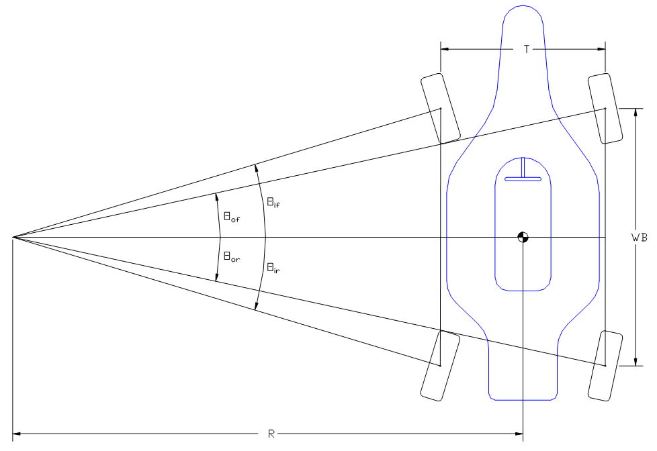

**Figure 1. Four Wheel Steering Diagram [1]**

The project will see the implementation of the four-wheel steering system onto the UTA F16 FSAE racecar. Although there is no car with an active rear steering system currently, the FSAE department has had a history with four-wheel steering in the past. Particularly in the early 2000’s, attempts were made in this field; one such vehicle exhibited the capability of operating in both parallel and counter-steering modes. However, the transition between the two modes was wildly undesirable leading to a freeze in future projects [2]. In the recent past, the group known as Quad Steering Solutions has designed and developed an electrically driven servo system for the rear. The system that was developed introduced a nonlinear gain and was designed for the purposes of implementation of FSAE racecars.

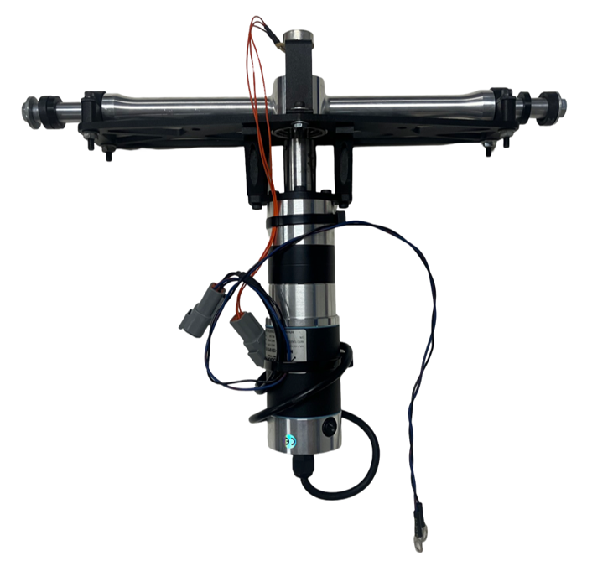

**Figure 2. Rack Assembly Received from Previous Team**

The focus here at Adaptive Steering Solutions is to implement the previous project's four-wheel steering system, shown in Figure 2, onto the F16 race car. The system will be designed in a way such that at small steering inputs the rack will not actuate, but at larger steering inputs the rack will actuate. Additionally, a constraint required for FSAE rules mandates that rear wheels will be limited to only 6 degrees of turning. Before the integration of 4WS can take place, an objective for the project was to develop a functional testbed that will simulate the system as installed on the car. This test bed allowed us to develop and test the protoboard and other control components used in the system. Another important feature of the test bed was allowing us to determine some initial gain settings for the steering controls.

**Design**

**Design Criteria**

* The Rear Steering system must follow FSAE rules which limit the rear steering angle at the maximum of 6 degrees.
* The system should only actuate at low-speed corners i.e. when the turn radius is small.
* The design needs to be integrated into an already existing F16 race car.

**System Overview**

The cornerstone of the entire system is the electrically driven servo system that actuates the steering rack. For the steering rack to be implemented adjustments to the F16 chassis and suspension components were made. The complete system is seen in Figure 3 and 4 below.

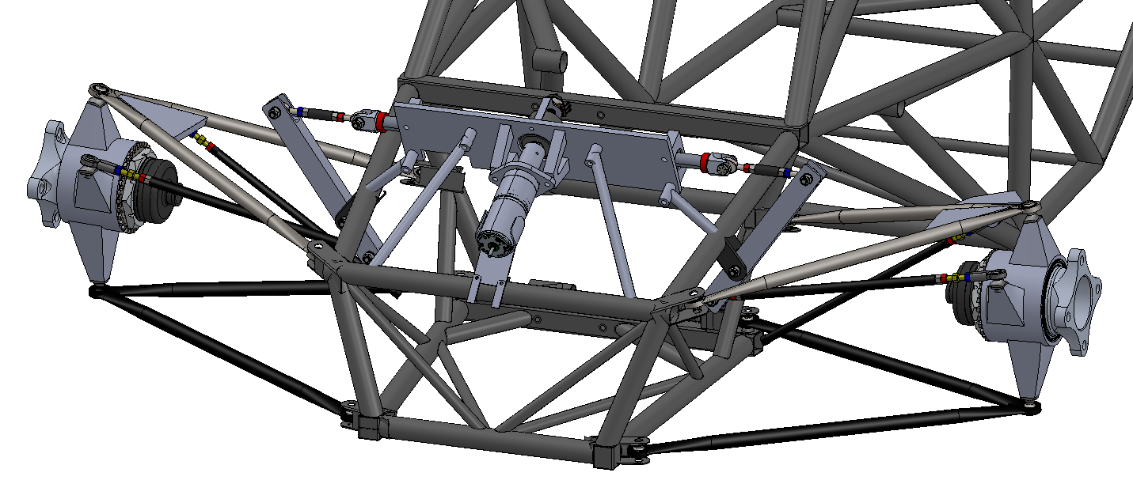

**Figure 3. Rear Steering System Components on car**

The first modification to the system is that the steering rack is placed above chain guard on the drive train. This decision was made to ensure proper packaging and to ensure it works with the location of the tie rod; which was tested for bump steer. (see Appendix C). From here, the steering rack outputs a linear motion which is transferred through the upper steering rod to the bell crank. The bell crank’s role is to convert the linear motion from the steering rack to the angular motion of the upright. This motion is relayed using a second, lower mounted tie rod. The upright’s function is the interface between the wheel hub and suspension links like the steering and control arms. The linear output of the steering rack will cause the bell crank to pivot which will steer the wheel via the uprights. The upright is where the 6-degree constraint is ultimately enforced at competition. This is accomplished with stops on the steering rack itself. This system requires kinematic analysis to determine the position of the control arms and tie rod linkages that align with the instant center of the control arms to achieve minimal bump steer.

**Suspension Modifications**

**Bell crank:**

Our preliminary design for the bell crank system is shown in Figure 4. A tab is welded onto the chassis where the bell crank is mounted and pivots about. A steering rod linkage connects the steering rack clevis to the bell crank to transfer the motion from the steering rack into the bell crank. Another steering rod linkage, known as the tie rod, attaches the bottom point on the bell crank to the steering arm on the upright. As the steering rack actuates one way or the other, it will push/pull the linkages and turn the upright which will turn the wheels one way or the other.

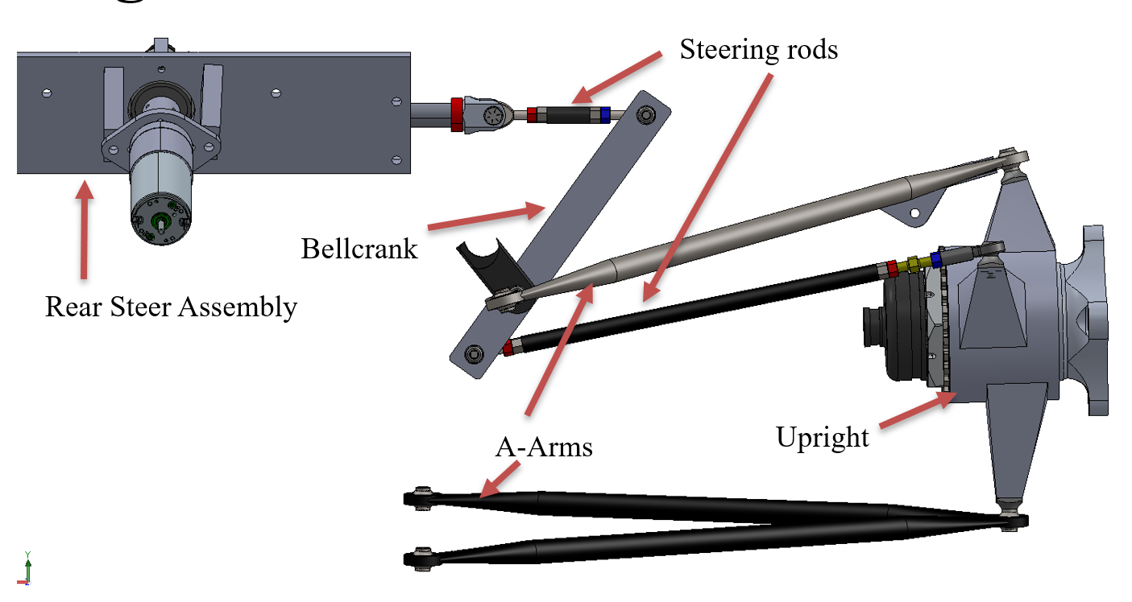

**Figure 4. Bell Crank System Diagram**

**A-Arms and Upright:**

The desired kinematics for rear steering was zero caster and king pin inclination (KPI), meaning that the upper a-arms and uprights needed to be redesigned. These values were desired because with the 6-degree steering limit, caster and KPI would have very little effect on handling so having both be zero allows for easier packaging. These would also change the forces seen in the steering rack at various maneuvers. The servo motor was not sized to consider these inputs. We fixed all the inboard points and the lower a-arm and only redesigned the upper a-arm moving the ball joint point to meet the new desired kinematic values. The lower and upper ball joint points mount to the upright, as well as the tie rod from the bell crank. These three points create the preliminary design for the upright shown in Figure 5.

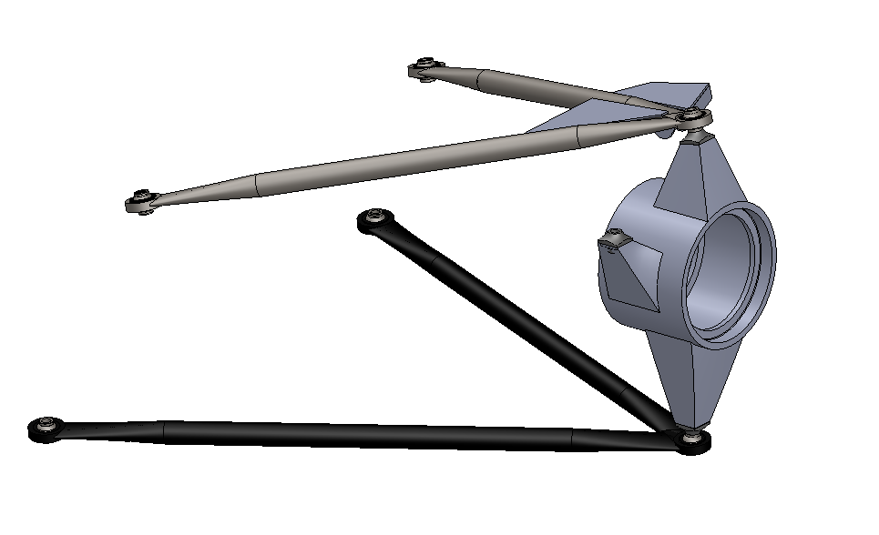

Ball Joint Points

Inboard Points

**Figure 5. A-Arm and Upright Design**

**Electronics/ Controls/ Test Bed**:

With the steering kinematics and design in place the next step was to start designing the testbed. Ultimately the goal for the testbed was to test the electronics and start developing the program that will control the system. We used an ESP32 microcontroller and other electronics shown in Appendix D to control the system along with the servo mounted steering rack. To design the physical test bed, we designed and 3D printed a saddle for the servo to rest in, a 3D printed steering wheel to mount on a potentiometer, and aluminum plate was welded together to mount the potentiometer and steering wheel. The testbed is shown in Fig. 5 with all the electrical components as well as servo steering rack.

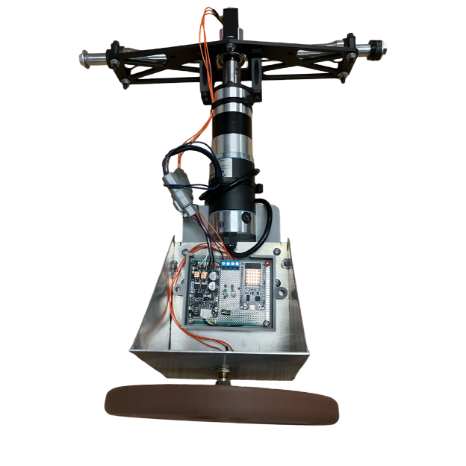

**Figure 6. Physical Testbed Configuration**

We took all the electronics from Appendix D and mounted them on a protoboard and by doing that had them in a separate enclosure. To run all the wiring throughout the system we decided to use 4-pin Deutsch connectors to have sealed reliable connections through the system. The testbed electronics were designed to be operated on the F16’s battery which is around 13.3V and this was done through a voltage regulator for the Microcontroller, and the rest was supplied to the motor driver for the servo. With the testbed being functional we then turned the protoboard into a PCB as shown in Appendix E. This was done to have a more robust system that would have less problems with wires coming loose from the protoboard. An enclosure was designed to hold the PCB on the car, and this kept the wiring from the sensors in a separate section from the servo wires.

**Controls:**

The control strategy used in our assembly relies on two potentiometers. The first is mounted to the input shaft of the existing F16 steering rack. This was done using a 3D printed, clamshell type bracket shown in Figure 7.

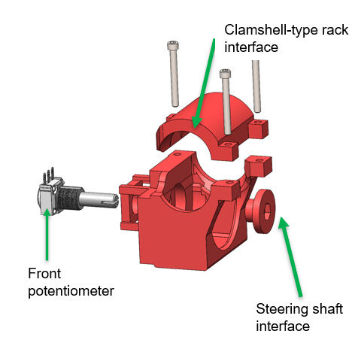

**Figure 7. Front Potentiometer Mount**

This is used as the input to the equations included in Appendix B giving the desired rear steer percentage. This percentage correlates with the 6-degree rear steer maximum constraint.

The actual rear steering position is measured using the second potentiometer that is integrated into our rear steering rack assembly. The controller will determine the error seen between the desired and actual rear steering rack position. Consequently, it will use a PD-type control strategy to drive the servo on the rear rack to appropriately minimize the error. This was tuned on the testbed to minimize the response time, overshoot, and oscillations. Several iterations were tried for PD values and those are included in Appendix B. It is also noted that this will almost certainly need further adjustment when implemented in F16. **Appendix F contains the code highlighted to make this easier for future work. Look there when looking to change the behavior of the system.**

**Manufacturing:**

The manufacturing work for the four-wheel steering project primarily took place on the first floor of Wolf Hall. The primary hubs of operation were the UTA Racing machine shop and the MAE machine shop. Using these locations, the team had full control over the manufacturing process, including several key machines such as the Bridgeport mill, Samstar lathe, drill press, bandsaw, water jet, and welding station. A common trend for much of the manufacturing is the use of the bandsaw to cut from the necessary billets for machining. Additionally, most of the parts went through a series of grinding and sanding operations to obtain optimal surface finish quality. The manufacturing and assembly of each system is highlighted below.

**A-Arms:**

To successfully manufacture the A-Arms, a jig must be assembled from the core pieces that will support the A-Arms. The A-Arm jig is comprised of three unique parts made of 6061 aluminum, the stand offs, plate, and tube holders. The standoffs were turned down on the lathe and then threads were tapped to be able to bolt it to the plate. The plate was cut from a sheet of aluminum using the circular saw and then squared off on the mill as well as having the holes drilled on the mill. Lastly, the tube holders designed to hold the arms were constructed using a billet cut from a bandsaw and then machined to spec on the mill. Figure 8 shows the diagram of the A-arm jig and assembly.

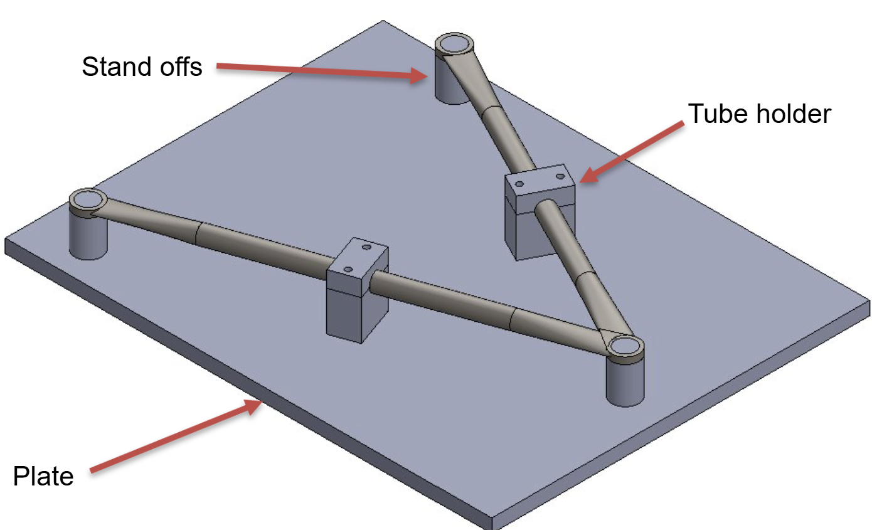

**Figure 8. A-arm Jig Layout**

The A-Arms themselves have 4 distinct parts made of 4130 steel: the sleeves, teardrops, tubes, and pull rod tab. The sleeves were made using the lathe, making sure the thickness of the sleeve was 0.25” as it is a critical dimension to ensure the bearing is staked properly. The teardrops were manufactured by outlining a SolidWorks 1-to-1 drawing cutout traced onto a sheet of steel. Using the drill press, a hole was drilled and then the rest of the profile was cut out using the bandsaw. The mill was also used to remove excess material and further shape the teardrop. The tubes were cut to oversized using the bandsaw and then trimmed down in the process of welding. Lastly, the pull rod tabs used .069” steel and relied on SolidWorks 1-to-1 drawings that were traced over the steel and then cut by the bandsaw.

The assembly of the A-arms consisted of welding all the components together on the jig. The sleeves and teardrops were bolted into the standoffs and then the tubes were pinched and coped on each end before being lined up in the tube holders. Once everything was lined up on the jig, the assembly was welded together. The pull rod tab was welded on the car once the A-arm was bolted into place. Once the A-arm was welded, we reamed out the sleeves and then staked the bearings, and then we painted the assembly, and it was complete. Figure 9 shows the final A-arm assembly on the car.

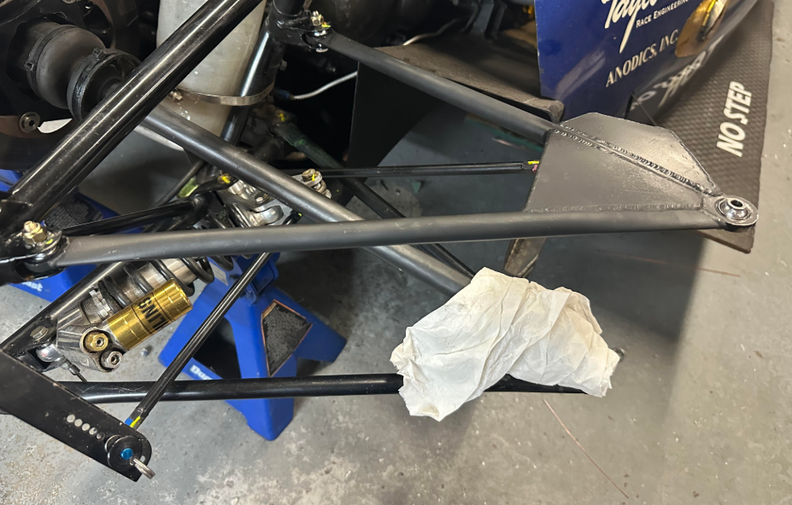

**Figure 9. A-arm Assembly on F16**

**Upright:**

The next major component is the upright jig that has 5 distinct parts made of 6061 aluminum: the plate, top, bottom, and steering arm stand offs, and the bearing race caps. Like the A-arm jig, the plate was cut from a sheet of aluminum and squared off and drilled using the mill. The standoffs this time came in three different parts based on their locations on the plate being top, middle, and bottom. The billets were cut using the bandsaw and then milled to spec as well as tapped to be bolted into the plate. The bearing race caps were turned down on the lathe, making sure proper fitment with the bearing race. Figure 10 shows the diagram of the upright jig and assembly.

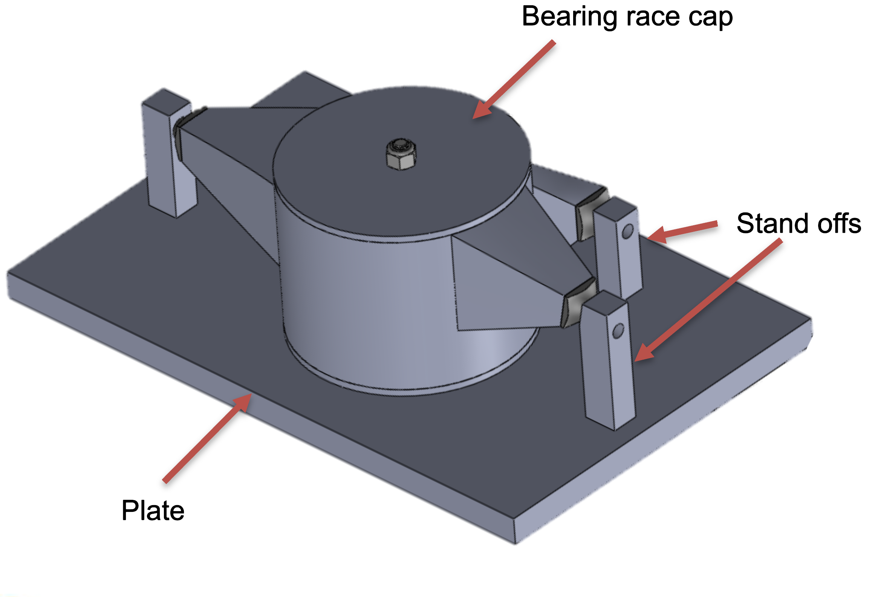

**Figure 10. Upright Jig Layout**

The formal upright part is made up of 4130 steel and is comprised of three parts: the bearing race, sheet metal parts, and bearing threaded inserts. The bearing race was an extensive lathe operation where a chunk of steel was turned down to be the bearing race. The sheet metal parts required a DXF file be sent out to the MAE machine shop so the Wazer waterjet can accurately and precisely cut out each part. The sheet metal parts were rusted after the operation and required extensive cleaning through sanding. The bearing threaded inserts were manufactured through a combination of lathe and mill operations. One inch round stock was turned down and drilled on the lathe and placed on the mill to be squared off. Figure 11 shows the completed welded uprights.

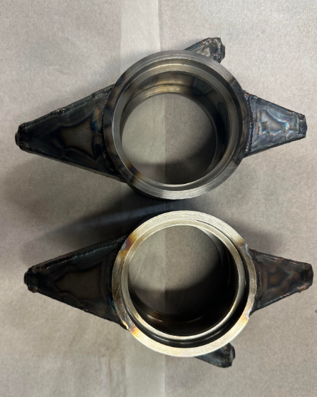

**Figure 11. Welded Upright Assemblies**

Once all the components of the upright were manufactured, the threaded inserts and bearing race were bolted down to the upright jig. The sheet metal parts were then lined up in their respective areas and the assembly was welded together. Once welding was complete, the upright was put back on the lathe for the bearing surfaces to be machined to final dimension. The bearings were then pressed in, and the uprights were painted before being mounted onto the car. Figure 12 shows the complete upright mounted onto the car.

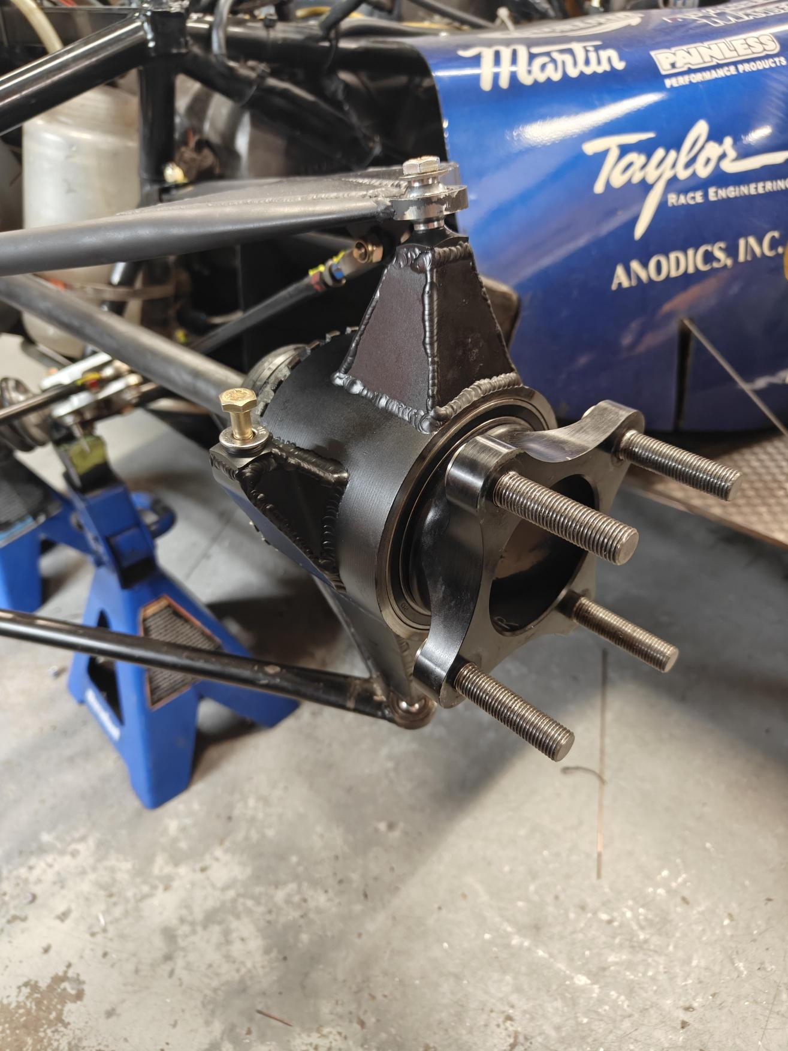

**Figure 12. Completed Upright on F16**

**Rear steer Assembly:**

The rear steer assembly contains four distinct parts made of 6061 aluminum: the mounting plate, rack mounts, stand offs, and pot mount. The mounting plate was cut on the bandsaw and then placed on the mill to be squared off. From here, the mill used a series of drilling operations to create multiple holes on the plate of different sizes to support the motor and other components. Both the rack mounts and stand offs billets were cut using the bandsaw, which were then completed using the mill. The pot mount was 3D printed instead of aluminum because it was a simple designed part where 3D printing was sufficient. Figure 13 shows the rear steering diagram with all the components.

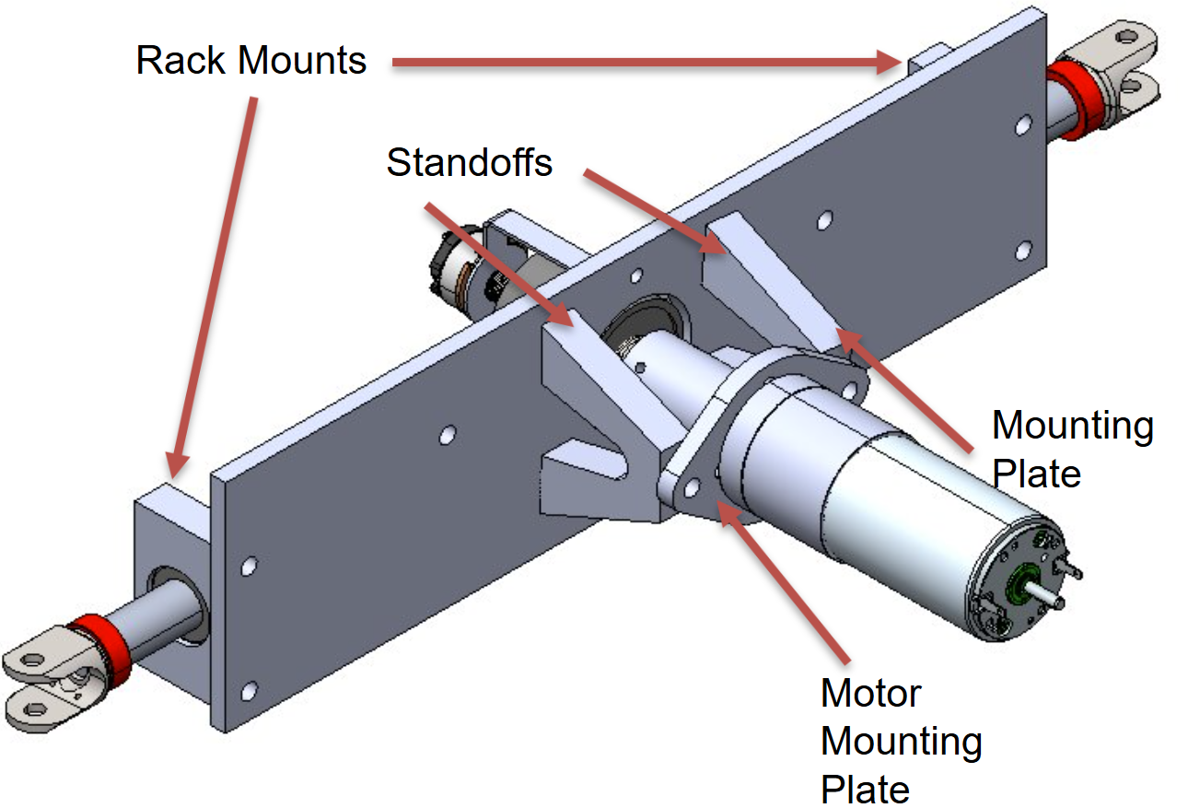

**Figure 13. Rear Steer Assembly Diagram**

The mounting plate was the base of the rear steer assembly. The rack mounts slid on each end of the steering rack and then bolted into the mounting plate. The motor was bolted into the motor mounting plate, which was bolted into the standoffs and the mounting plate. The potentiometer was attached to the pot mount which was bolted into the mounting plate. Figure 14 shows the completed rear steering assembly.

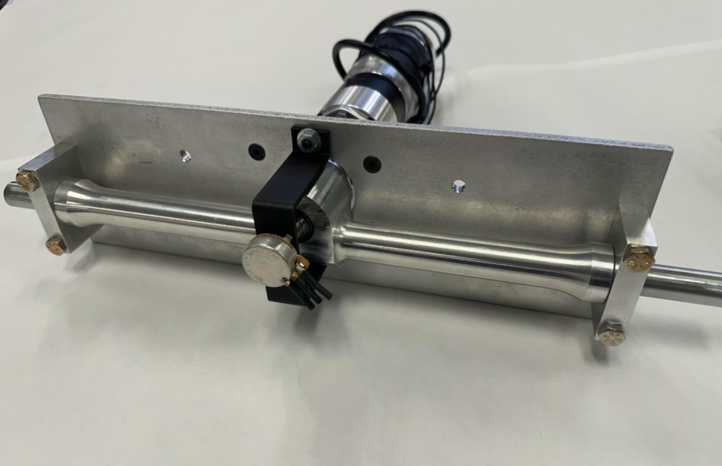

**Figure 14. Completed Rear Steer Assembly**

**Bell Crank:**

The bell crank system was one of the last ones to be manufactured due to its relative simplicity compared to the other, more demanding parts. The system is comprised of a few components: the bell crank, tabs, top hats, and oil light bushing. The bell crank was machined on the mill after cutting the aluminum billet on the bandsaw. The holes on the bell crank are key as they help define a three-to-one motion ratio that's required by the motor on the rear steer assembly system. The tab was coped on the mill using 1” 4130 steel square stock. The top hats and oil light bushings were machined on the lathe, and fitment was checked to ensure ease of assembly. Figure 15 shows the completed bell crank assembly.

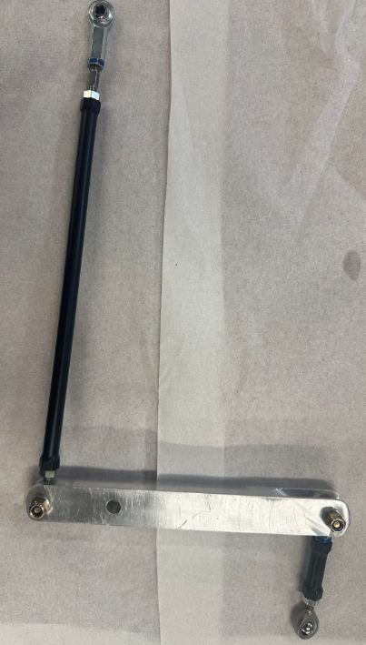

**Figure 15. Bell Crank System**

The assembly of this system was critical since the placement of the bell cranks will determine the location of the tie rods. This is paramount because improper placement that disregards the specific CAD location based on the Mitchell data will result in bump steer. Therefore, a series of fixtures and jigs were placed on the chassis to locate the precise location of the bell crank tabs to be welded onto the frame. With the tabs welded, the bell cranks can be mounted and attached to the tie rods. Figure 16 shows the completed bell crank assembly mounted onto the car.

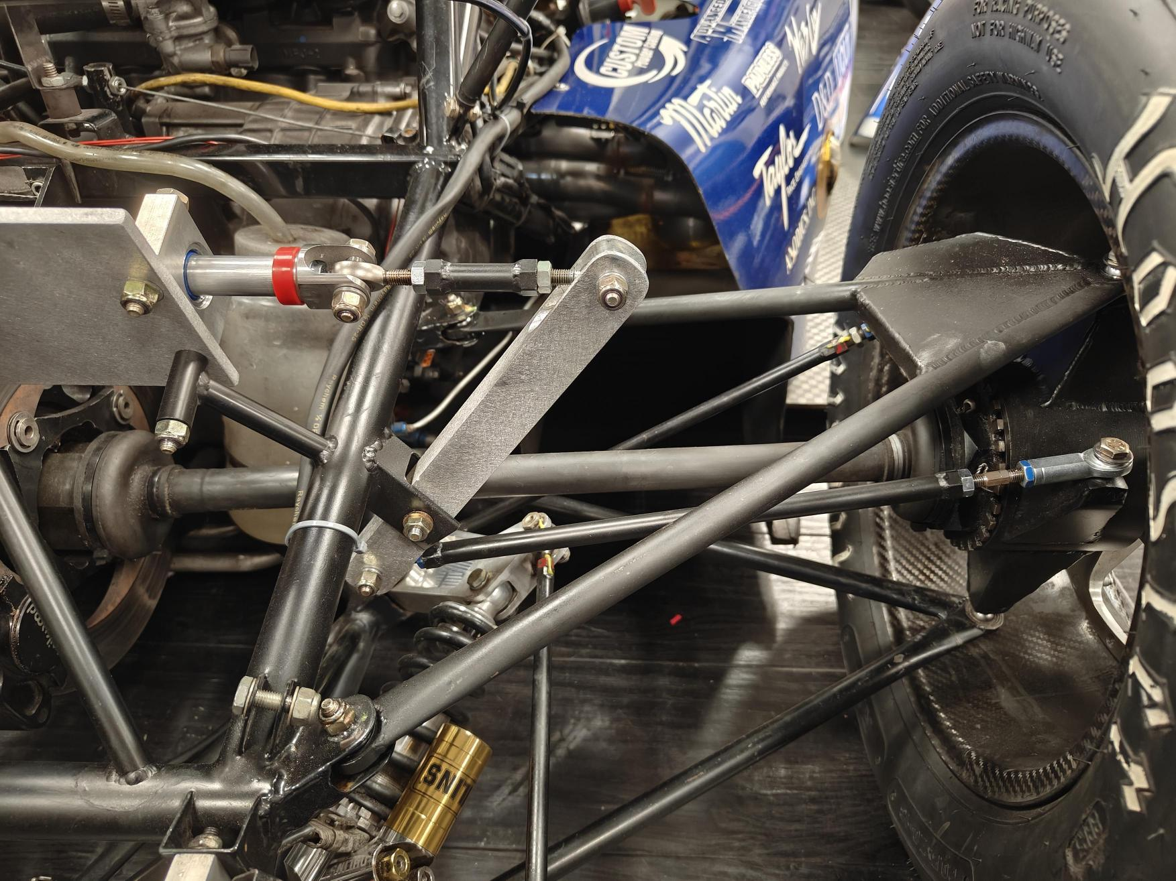

**Figure 16. Bell Crank Assembly on Car**

**Rods:**

The rods for the system used 4130 steel and had three key parts: the steering rods, tie rods, and inserts. Both the steering rods and tie rods relied on stock tubes that were cut to length using the bandsaw and then placed on the lathe to get it down to accurate dimension. The top hat inserts were turned down on the lathe using 4130 hex stock. The top hats were welded into each end of the tubes, and then the rod ends and adjusters were assembled. Figure 17 shows the completed rod assemblies.

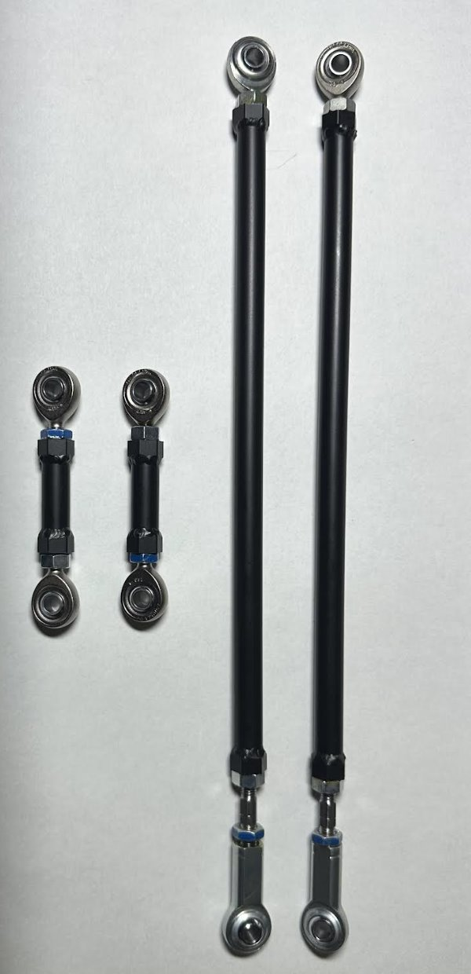

**Figure 17. Steering and Tie Rod Assemblies**

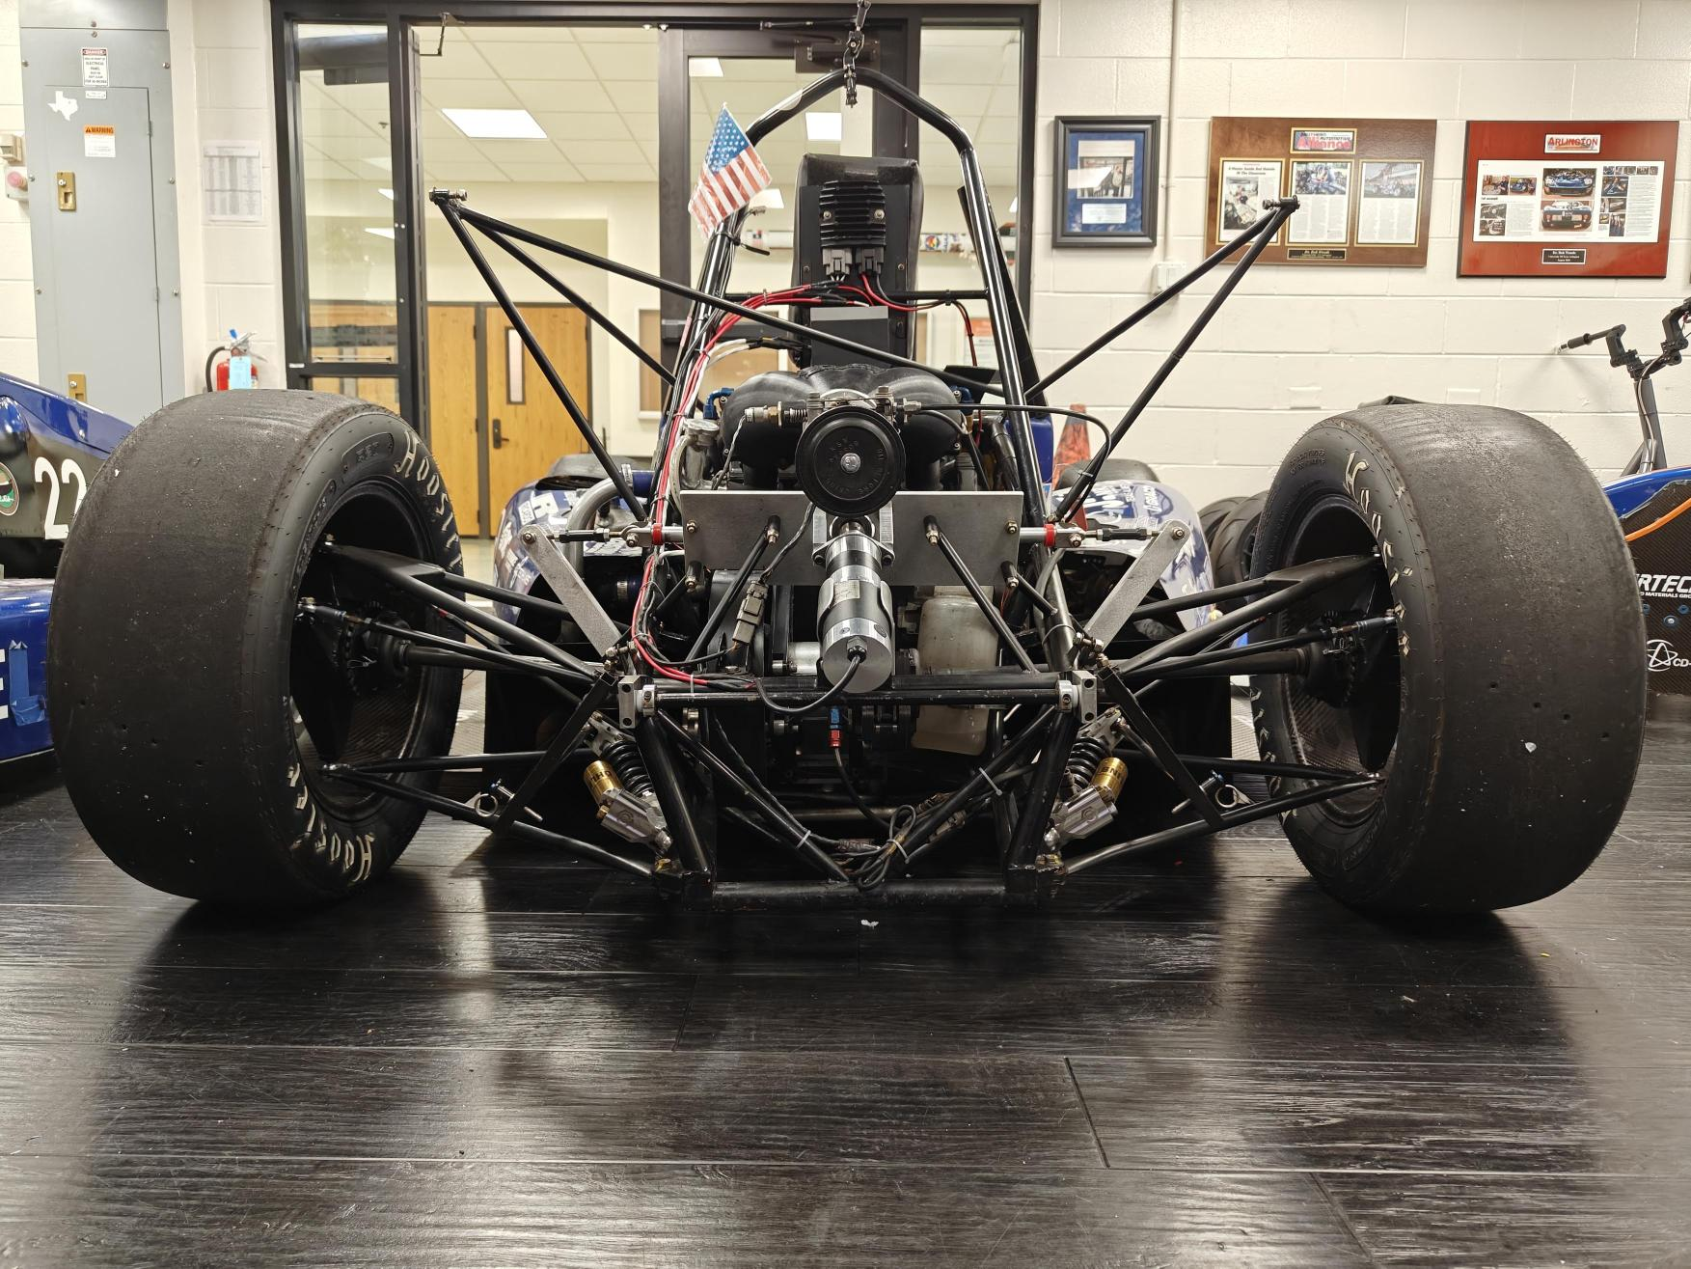With all the assemblies manufactured and assembled, the total assembly on the car can be completed. Having the complete assembly mounted on the car, we were able to wire the motor and PCB as well as do static testing to make sure everything was working correct before driving it. We did a complete alignment on F16 as well as weight on wheels before taking it out to drive. Figure 18 shows the entire assembly mounted on F16.

**Figure 18. Total Assembly on F16**

**Conclusion**

Adaptive Steering Solutions has designed a system to integrate Quad Steering Solutions electronic servo steering system into UTA Racing’s F16 car. We have reworked the rear steering kinematics and redesigned the rear upper a-arms, bell crank, and upright to meet our desired parameters of zero caster and king pin inclination. Before implementing the electric servo system onto F16, we developed a tabletop testbed to assemble, validate, and tune the system’s electronics. After implementing the system on F16, the testbed values resulted in a drivable car. Further testing will be needed on track to determine if values need further refinement. Overall, the system worked well as designed. This system will be useful for further development by the UTA Racing team in their future endeavors.

**Future Work**

With the four-wheel steering system fully integrated, the team was able to show the viability and functionality of four-wheel steer as a proof of concept. Adaptive Steering Solutions recommends several modifications and design improvements for the future integration of four-wheel steering. One such area of improvement will be the overall weight reduction through optimization of several components when implementing four-wheel steering. The team investigated alternatives such as CNC for the uprights, but this came with the cost of removing manufacturing timelines out of our team's control. This is an area the team hopes gets explored in the future. The control system components have been completed and installed on F16. The scope of this project limited how the team could most effectively design around the packaging of those control systems, which had constraints that were imposed by F16 and previous group design decisions. With information gathered from this project, future racecar work will have four-wheel steering in mind. Therefore, future vehicle systems can have a better understanding of packaging. Additionally, the team recommends that the four-wheel steering system should be optimally tested and tuned extensively, as the team had little time performing a comprehensive examination of system performance. The electronics did not have a way to log the data while driving without having a laptop connected while driving. This needs some additional DAQ that will allow the controller and equations to be better tuned to any application. With these considerations in mind, the team believes four-wheel steering will be beneficial to UTA racing.

**References**

[1]. Woods, Bob, “4-Wheel Steering Analysis 2022,” February 10, 2022, UTA Internal Documentation, file: “4 Wheel variable steer 2022.docx”

[2]. SAE International, “Formula SAE Rules 2025, Version 1.0,” September 6, 2024, https://www.fsaeonline.com/cdsweb/app/NewsItem.aspx?NewsItemID=379e4a8a-80a2-4a74-87c2-6f2de4212270

[3] Wescott, Tim, “PID without a PhD”, August 14, 2018

**Appendices**

**Appendix A – Turn Radius**

Steering Wheel vs Wheel Angle Test

The circumference of F22s steering wheel was marked every 10-degrees. The 0-reference mark and pointer were aligned at the top of the steering wheel while the wheels were aligned straight ahead. This is shown in Fig. A1. Next, the steering wheel was turned from its centered position at 10-degree intervals until full lock was achieved. Considering this approach the upscale, a downscale measurement was also performed similarly from full lock back to the centered position.

These measurements were taken at each of the front wheels. However, this was performed only in the direction of turning that would cause the measured wheel to be the outside wheel of a turn. This gives us plots of the steering wheel angle vs wheel angle for either front tire, if it's the tire on the outside of the turn.

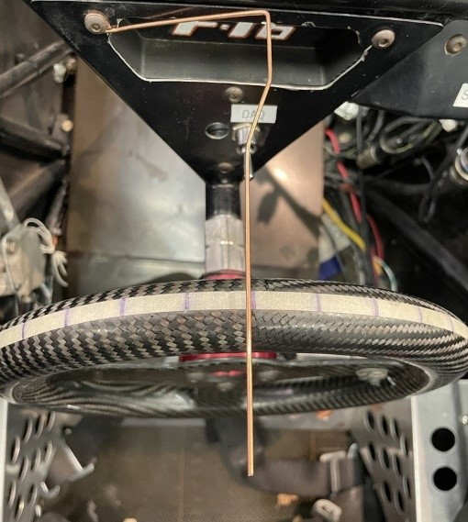

**Figure A1. Steering Wheel with Indicator and Degree Lines**

For the wheel, a large straight metal plate was placed on the side of the left wheel as seen in Figure A2. A string of yarn was placed against the plate and was taped down to the floor. With the car wheels facing forward, the first piece of string represented a 0-degree wheel angle. Next, the driver turns the steering wheel to the left with one tick mark correlating to 10-degree steering angle. The metal plate is then picked up and placed to line up against the now-turned wheel. The string is aligned to the metal plate and tapped down. The process of turning the wheel, placing the metal sheet to serve as a straight edge for the string which will eventually measure the wheel angle. A complete representation of the array of springs is seen in Figure A3. This is repeated until the left wheel is turned fully to the right until it locks.

Once the lock had been reached a high-quality photo was taken to measure the many strings of yarn using the Digital Image Correlation method (DIC); which will be used to measure the wheel angle. After the picture is taken remove the tape and strings to conclude the upscaling measurements. Ultimately this will show the correlation between the steering angle from the steering wheel to the wheel angle from the strings on the ground. Now to begin the downscaling process the wheel is turned back to its initial position, but while placing the metal plate and taping string at each increment.  Once this is complete, take the photo that will be used for DIC for downscaling. Now repeat this same process for the right wheel making a left turn for both upscale and downscale.

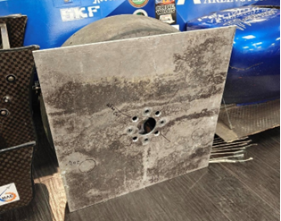

**Figure A2. Metal Plate Alignment**

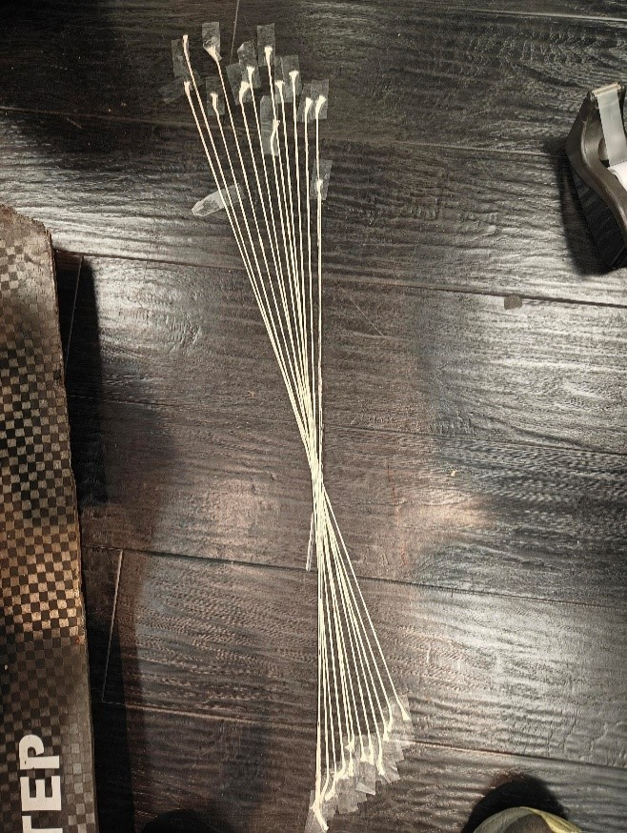

**Figure A3. Wheel Angle String Placement**

The plots displayed below are the data regarding the relationship between steering angle and wheel angle dependent on the turn. Figure A4 depicts a left turn and its corresponding inner and outer wheel measurements, while Figure A5 shows a right turn. It was noted that during the test, the left turn locked at 95 degrees, and during the right turn locked at 105 degrees. The possible reason for this discrepancy is that the steering rack wasn’t centered prior to the experiment. Both Figures A4&A5 represent the averages of upscale and downscale data thus reducing possible errors.

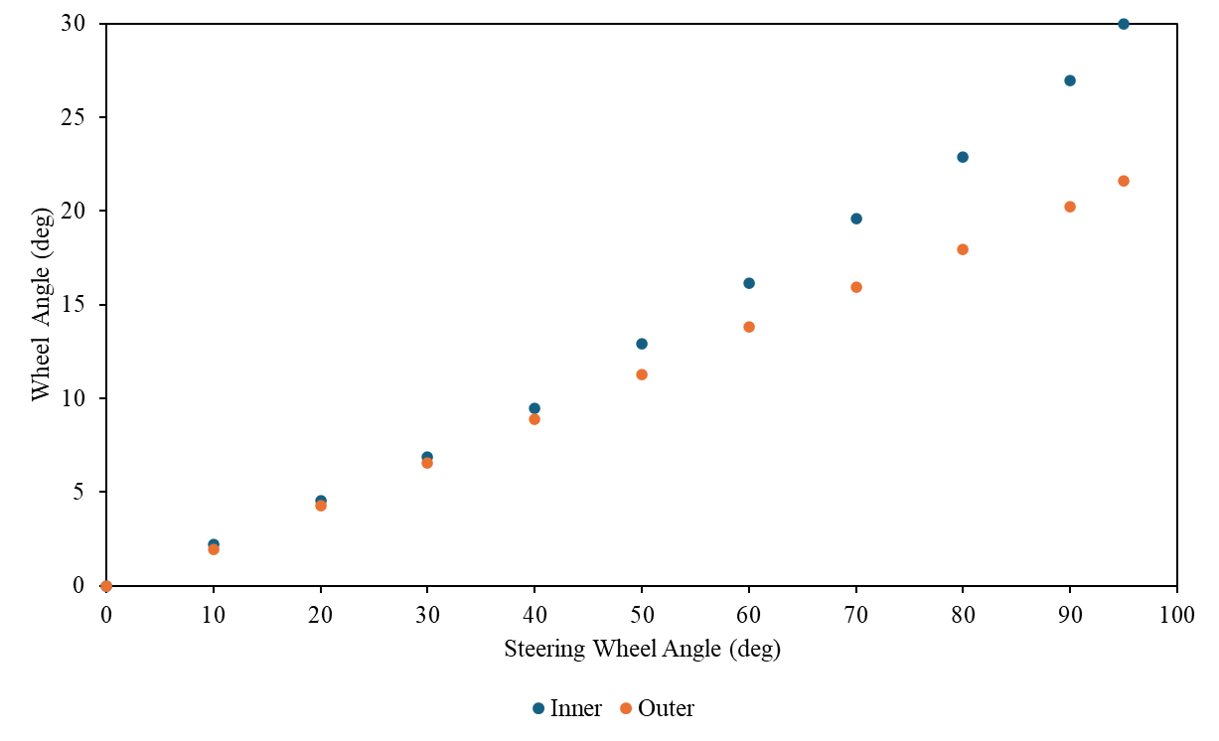

**Figure A4. Left turn Inside vs outside Wheel**

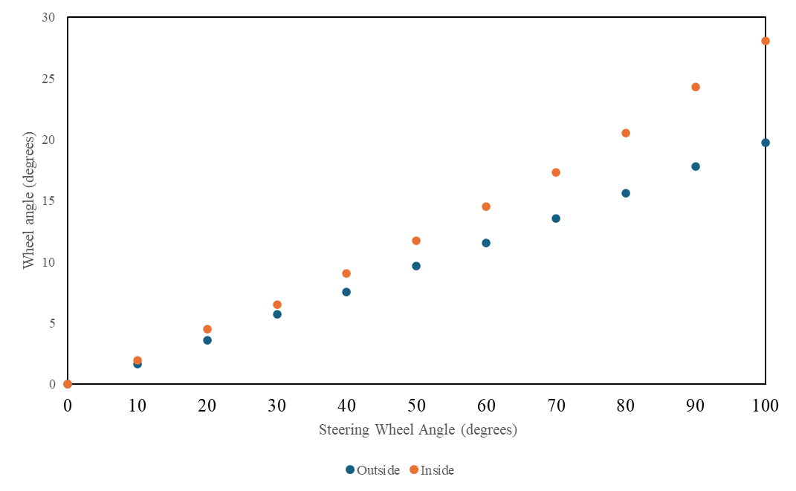

**Figure A5. Right turn Inside vs outside Wheel**

To calculate the turn radius, we needed a few measurements from the car such as the Wheelbase (WB) and the Front Track Width (TF). The following equation is used to calculate the turn radius of the outer wheel given the wheel angle δ0*𝛿0*. We took measurements of the steering angle and the wheel angles on the way from 0 to 100 degrees and from 100 degrees back down to 0. We did these upscale and downscale measurements on both turning directions to help negate the error. An average was calculated for the wheel angle based on the average of the upscale and downscale measurements of both the left and right wheel.

$R_{o}=\frac{\left(\frac{WB}{\tan\left(δ0\right)}-\frac{TF}{2}\right)}{12}$ (1)

In Eq. (1) is the equation we used to calculate the turn radius, and the wheel angle δ0*𝛿0*  is associated with a steering wheel angle input. With the above equation and the wheel angle measurements taken from the car we can calculate the range of the turn radius for both left and right. The Wheelbase for F16 is 66” along with the Front Track Width being 49.5” and Eq. (1) accounts for the values being in inches and converts the output to feet.

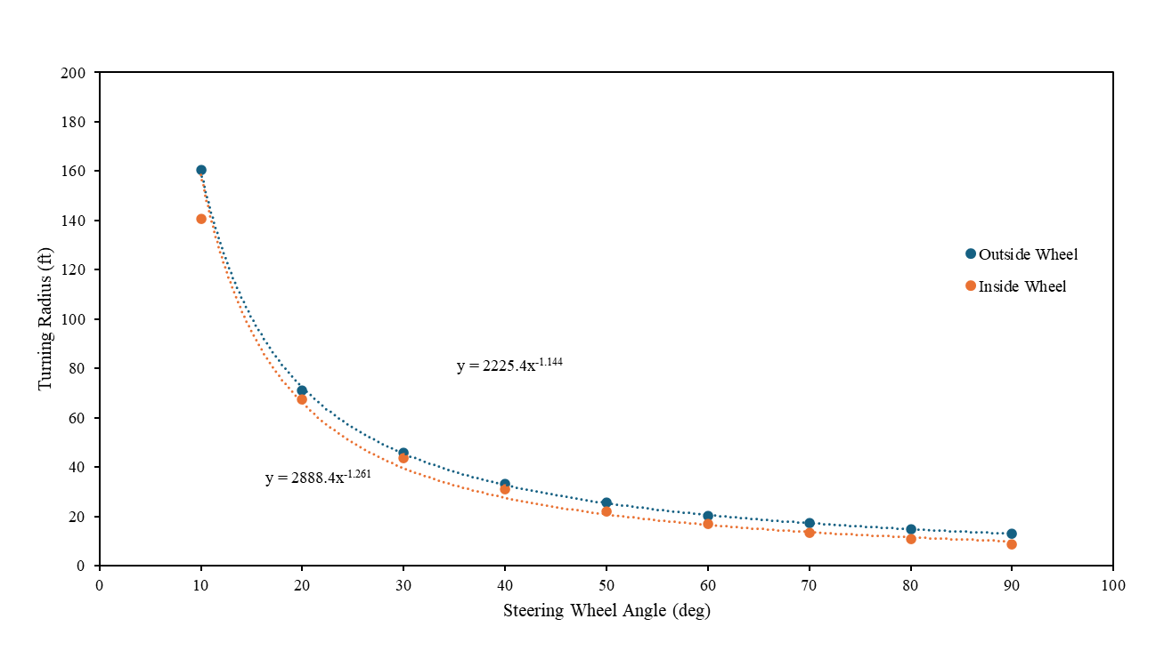

**Figure A6. Turn Radius Going Left**

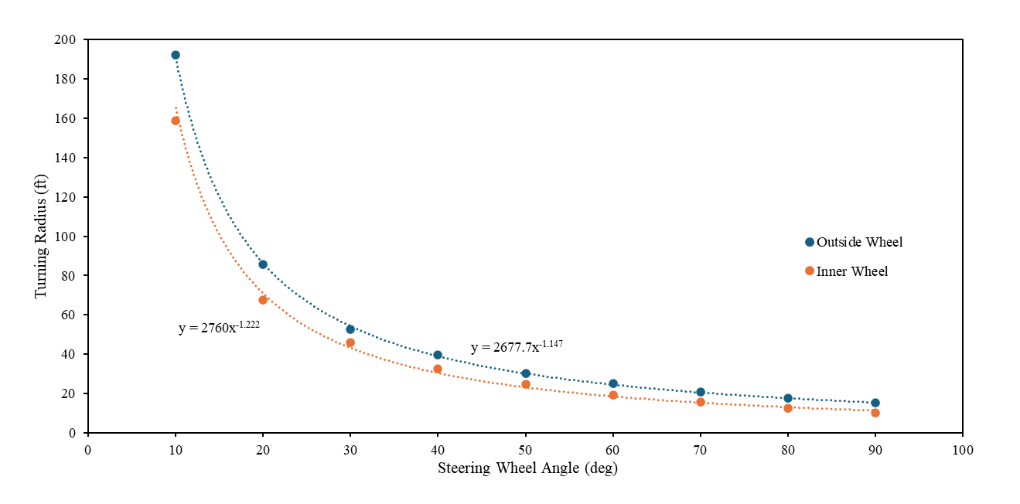

**Figure A7. Turn Radius Going Right**

The plots above show the steering angle and the turn radius at that steering angle, it was calculated using the wheel angle which was measured above. Figure A6 shows the inner and outside wheel steering angle vs turn radius for a left turn. Figure. A7 shows the inner and outsider wheel steering angle vs turn radius for a right turn.

The F22 test was performed because the previous F16 test data had substantial amounts of play in the steering system. It was noted that there was around 5 to 10 degrees of steering wheel rotation. It was observed that the F22 vehicle had less translational and rotational play than its 16 counterpart, but the degree difference for the F22 to reach full lock was approximately 10 degrees. This probably stems from the steering rack not being centered before measurements were taken. Ultimately the turn radius data effectively shows real experimental data of steering wheel angle vs turn radius that is in line with theoretical concepts.

**Appendix B – PID and Controls**

There is an equation that is derived from Dr. Woods data that relates the front turn radius to the rear steering percentage. The Four-Wheel Variable Counter Steering report has all the inputs (Turn Radius) and outputs (Percentage Rear Steer) and the equation that is formed from this table is shown with Y being the percentage rear steer and X being the turning radius.

$$Y= -50\tanh\left(0.1X-4.5\right)+50$$

**Figure B1. Dr. Woods Points for Turn Radius and Rear Steering Percentage**

In the Turn Radius report, we experimentally measured the Steering Wheel Angle vs the Turn Radius for both left and right turns. The turn radius was measured using the outside wheel of each respective turn direction. Also noted is this particular test was performed with the F22 car. The test was initially run with F16, but the data showed some errors. This test will be rerun with F16 after an alignment is performed. Consequently, we have the following equations for the Left Turning Radius and the Right Turning Radius which is shown with X being the turning radius and $θ_{w}$ being the Steering Wheel angle.

$X=2760{(θ_{w})}^{-1.222}$ $θ_{w}>0$ Left Turn

$X=2677{(θ_{w}*-1)}^{-1.147}$ $θ_{w}<0$ Right Turn

In the right turn equation, the degrees are multiplied by -1 in order to make the value positive and easier to read. The centered steering wheel position is considered to be the Top Dead Center (TDC) value. This is the zero reference point from which calculations are performed. The wheel angle is positive CCW from TDC and negative CW from TDC. In the code, this logic is applied, and the percentage rear steer equation is turned into the following. Here, the Y output gives the percentage of total rear steer desired.

$Y= -50tanh⁡(0.1\left(2760{\left(θ_{w}\right)}^{-1.222}-4.5\right)+50$ $θ_{w}>0$ Left Turn

$Y= -50tanh⁡(0.1\left(2677{\left(θ_{w}*-1\right)}^{-1.147}-4.5\right)+50$ $θ_{w}<0$ Right Turn

Knowing the desired rear steering angle, the rack assembly servo motor is driven to move the steering rack to a desired position. The assembly has a second potentiometer mounted to it. This potentiometer is used to determine the actual rear steering position. The rear potentiometer has 270 degrees of motion making it 135 degrees each way, so the percentage is multiplied by the degrees of the specified turn therefore outputting the desired rear potentiometer angle and controlling the servo-steering rack to make the measured reach the desired. If the percentage of rear steer is 50% then the desired rear potentiometer angle is 67.5 degrees, and the servo will be powered to make the measured potentiometer value reach 67.5 degrees.

A PID control strategy was implemented to appropriately drive the servo to match the desired and actual rear steering position.

PID Tuning

Currently we are only using the Kp and Kd terms of the PID Controller and using the calculated desired rear potentiometer angle compared with the measured actual rear potentiometer angle. Once implemented in F16, the system will likely need to be retuned with the potential for a Ki term being needed there. After testing and iterations using the testbed, the values of Kp = 0.1 and Kd = 0.008 showed the measured rear potentiometer angle reaching steady state earlier than previously tested values.

**Figure B2. System Response Using PD Controller**

Measured Rear Steer Percentage

In the Four-Wheel Counter Steering report from Dr. Woods, there is a table of data that has the Turning Radius and the desired rear steering percentage, and those points were put on an excel plot. The control setup was then formatted to output the Turning Radius and the calculated Percentage rear steer from the above equation and the data was plotted alongside the previous points outputting the following plot.

**Figure B3. Microcontroller Calculated Values Alongside Dr. Woods Data Points**

**Appendix C – Bump Steer Analysis**

When implementing the four-wheel steering system, the suspension systems must be designed in such a way that bump steer is accounted for. The bump steer is when the vehicle wheels move on their own without input from the driver as the suspension compresses and decompresses. To achieve near-zero bump steer, a few criteria must be met. The first is that the location of the tie rod must fall between the upper and lower control arms. Specifically, an imaginary line must run through the endpoint of the upper control arms to the endpoint of the tie rod to the lower control arms. The same logic is applied to the other side of the rods as well. More importantly, the centerline of all three rods must intersect at a location known as the instant center. Both height and length are two predominant factors that dictate how pronounced the bump steer will be.

  The process to achieve an appropriate level of bump steer relied on both SolidWorks and Mitchel kinematics software. SolidWorks contained the master assembly suspension sketch and Mitchel would analyze the sketch and determine the bump steer by examining the toe angle. To obtain relevant results, the SolidWorks coordinate system must be in line with the coordinate system. Next, the suspension system coordinates such as the upper and lower control arms are inserted into Mitchel along with other vehicle information like the wheelbase. Now, on SolidWorks, construction lines must be made connecting the pivot points of all the rods, and centerlines will be constructed so that all three lines intersect at the same point. With proper constraints, a SolidWorks tie-rod configuration can be achieved.

Once the configuration is obtained, the coordinates of the tie rod’s inboard and hub points must be imported into Mitchel’s steering section as seen in Figure C1. After this by selecting compute Mitchel will generate the corresponding bump steer. To compile bump steer data, the roll values must be held to a constant zero while adjusting the ride values (in) from -1 to 1 in increments of .25. It's important to note that achieving near-zero bump steer in the cases for this project is impractical; therefore, a target bump steer value should be 0.05 degrees. The proper location of the tie rod will be identified in an extensive, iterative process where the inboard and outboard points are adjusted until the targeted value is reached.

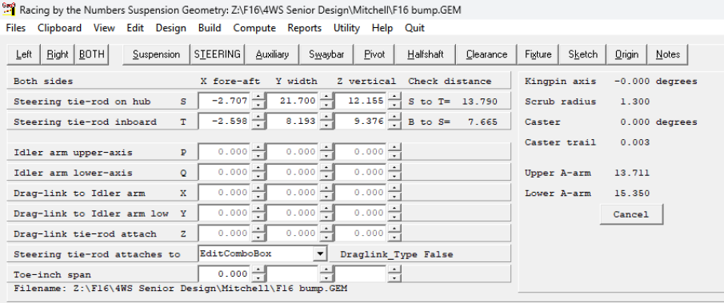

**Figure C1. Mitchel Steering Input data**

While finding the point on the tie rod, it was observed that the closer the rod was to the middle the smaller the bump steer values were. However, the first location that was sufficient for Mitchel had complications in SolidWorks from a packaging standpoint as the tie rod was too close to one of the suspension rods. Therefore, it was decided that to fix this issue the location of the inboard point will be moved further outwards in order to prevent packaging issues and maintain an appropriate level of bump steer. The Figure C2 below represents the adjusted configuration showing the purple tie rod inboard point being moved outwards to account for the packaging constraints.

Old Tie Rod

Upper Control Arms

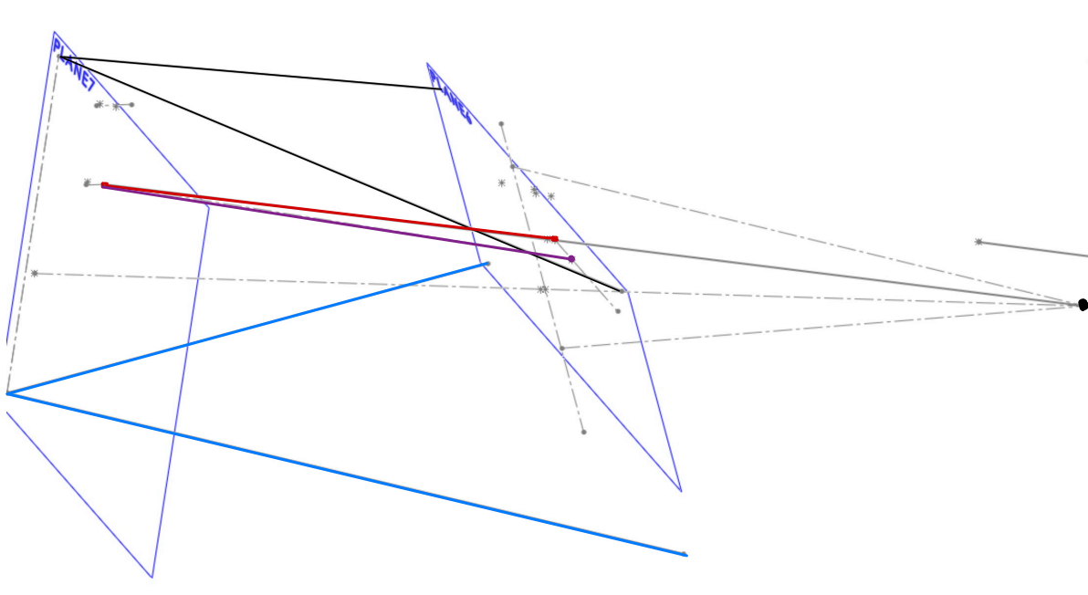

IC Point

New Tie Rod

Lower Control Arms

**Figure C2. SolidWorks Adjusted Configuration Showing New and Old Tie Rod**

In the data that was obtained seen in Figure C3, there is almost a linear relationship between the toe (deg) and ride height (in). On end constraints, point -1 has a toe value of -0.028 degrees and the opposite end has a value of 0.05 degrees. When examining a previous case study on bump steer this relationship shows the tie rod having the correct length but the wrong height. However, as stated previously the goal isn’t to achieve an absolute zero bump steer but to get it as low as possible while considering external factors such as packaging therefore even with this relationship the results are acceptable and will be used in the suspension system.

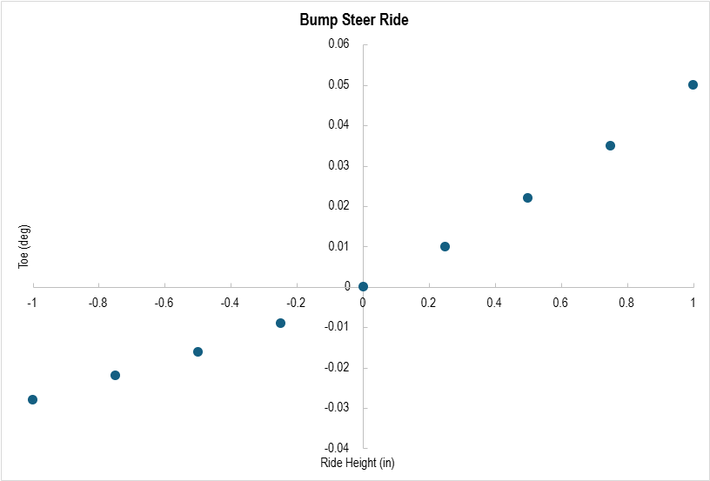

**Figure C3. Bump steer Toe vs Ride Height**

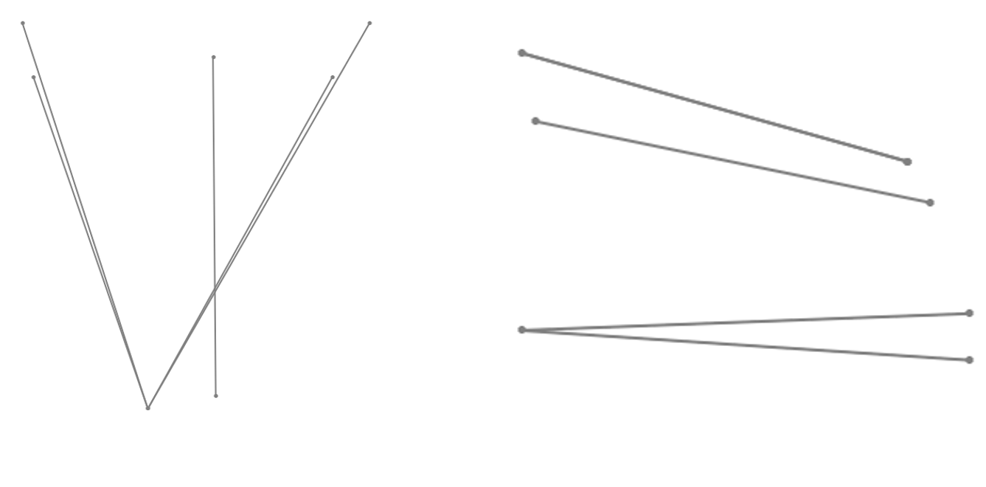**Figure C4. Final CAD Configuration Top and Side View**

**Appendix D – Electronics and Code**

The electronics are designed to be ran off of the FSAE 12V batteries that are used in the car to simplify the system. The Microcontroller that was chosen for this project was the ESP32 and the specs for the controller are in Table D1.

**Table D1. Microcontroller Specs**

|  |  |
| --- | --- |
| ESP32 – DEVKIT – V1 | |
| Operating Voltage: 3.3V | SPIs: 2 |
| Input Voltage: 7-12V | I2Cs: 3 |
| Digital I/O Pins (DIO): 25 | Flash Memory: 4 MB |
| Analog Input Pins (ADC): 6 | SRAM: 520 KB |
| Analog Output Pins (DAC): 2 | Clock Speed: 240 MHz |
| UARTS: 3 | Wi-Fi: IEEE 802.11 b/g/n/e/i |

With the ESP32 Microcontroller we had some previously passed down electronics as this is the continuation of a prior attempt at this project. We were given a Cytron MD13S motor driver that is used to communicate the direction and PWM signals from the microcontroller as well as take in the 13.3V power source from the battery and operate the servo. To have the correct input voltage into the Microcontroller we had to use a L7805 Linear Voltage Regulator and 1µF Capacitors to drop the voltage from 13.3V. For the sensors we also chose to use 10K rotary potentiometers with a linear taper and these were connected to the input shafts of both the front and rear steering racks. We decided to mount all our electronics on a protoboard and do so using a modular design. With all the wires that are connected to our protoboard we are using Deutsch connectors to have a sealed reliable connection and with our potentiometers when it comes to the protoboard we decided to solder a terminal block onto the protoboard for easy troubleshooting. In Fig. D1 we have the protoboard assembly mounted in a printed PLA Enclosure to lower the chance of any short circuiting.

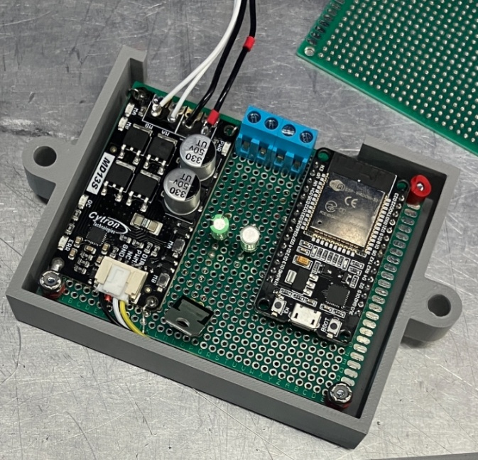

Cytron MD13S Motor Driver

L7805 Voltage Regulator

Potentiometer Terminal Block

ESP32 Microcontroller

**Figure D1. Protoboard Assembly in Enclosure**

The electronic components that are used in this project are as follows:

* ESP32 Devkit V1 Microcontroller x1
* Cytron MD13S Motor Driver x1
* L7805 Linear Voltage Regulator x1
  + Mouser #: 511-L7805CV
* 10K Rotary Potentiomer Linear Taper x2
  + Mouser #: 72-BR07230301
* 4 Pin Deutsch Connectors (M-F) x2
* 1 μF Capacitors x2

When this system was assembled, and the electronic configuration was tested and verified to be functional the code layout and structure were designed. The main code aside from the build files was written in C and was structured so that tuning and adjustments for future implementation will be simplified. The code works in the way that it takes in the front steering input from the potentiometer and through the measured equations from the car converts that to a corresponding turn radius. With the turn radius measurement, we can from Dr. Woods equation get the percentage of rear steering and then it calculates the desired rear steering. From the desired rear steering we take the previously mentioned PD strategy and compare the desired rear steering position to the measured rear steering position and increase the duty cycle for the servo to match the desired rear steering position and measured rear steering position. The main.c code is attached below but excludes the header files that contain the cars measured information.

#include <stdio.h>

#include <math.h>     //The C math library that is used for some of the complex math functions needed

#include "driver/gpio.h"    //The header file needed to use GPIO Pins and functions

#include "driver/ledc.h"

#include "freertos/FreeRTOS.h"      //A header needed to use serial communication

#include "freertos/task.h"      //A header needed to use delays

#include "driver/adc.h"     //The header file needed to use ADC pins and functions

#include "sdkconfig.h"     //Will have the pin setups and variable names

#include "TurnRadiusCalc.h"     //The header file for turn radius calc has the coefficient and power values for the function of each wheel

#include "pwm.h"        //The header file where the PWM Values will be stored

#include "RearAngle.h"

double FS_SteeringAngle; //Input Front Steering Angle, set to -91 for testing the angles, whenever actually implemented this will not have a value

double RS_SteeringAngle;        //Input Rear Steering Angle

double LW_Angle;    //Left Wheel Angle

double RW_Angle;    //Right Wheel Angle

double TR_Left;     //Turn Radius Left Wheel Right Turn

double TR_Right;    //Turn Radius Right Wheel Left Turn

double IDEAL_RS_ANGLE;

double RS_TR_RIGHT;

double RS_WA_RIGHT;

double RS_TR_LEFT;

double RS_WA_LEFT;

double RT_Percentage;

double LT_Percentage;

double RS_Deg;

double deadband = 0;

//double Gain_Input;    //Not sure if this will be used

//The amount of 'clicks' you want to be able to turn the rear steering adjustment knob

int ADJUSTMENT_KNOB_VALUE;      //The value of the adjustment knob that will be used on calculations

#define LED_PIN 2       //This is for the onboard LED (Status LED)

#define FAN_PIN 23      //This is for the constant fan to cool the controller

#define FRONT_STEERING_POT_PIN ADC2_CHANNEL_7 //This is the front steering pot       ADC1_CHANNEL_7 Corresponds to GPIO35 on the pinout diagram

#define REAR_STEERING_POT_PIN ADC2_CHANNEL_5 //This is the rear steering pot        ADC1_CHANNEL_6 Corresponds to GPIO34 on the pinout diagram

#define ADJUSTMENT_POT_PIN ADC1_CHANNEL_4 //This is the adjustment pot      ADC1_CHANNEL_4 Corresponds to GPIO32 on the pinout diagram

//#define MOTOR_DRIVER_1PIN  25      //This is the Motor Driver 1 pin correspodning to GPIO27

//#define MOTOR_DRIVER_2PIN 14        //This is the Motor Driver 2 pin corresponding to GPIO14

#define MOTOR_PWM_PIN 18        //This is the PWM pin corresponding to GPIO12

#define DIR_PIN 19

#define ADJUSTMENT_AMOUNT 7     //The amount of clicks the potentiometer will have, this only needs to be adjusted right here

typedef struct {

    double Kp;

    double Ki;

    double Kd;

    double previous_error;

    double integral;

} PID;

double Kp = 0.1;        //The Kp value of the PID

double Ki = 0.000;       //The Ki value of the PID

double Kd = 0.008;        //The Kd value of the PID

PID pid;

void setup_pid(PID *pid) {

pid->Kp = Kp;

pid->Ki = Ki;

pid->Kd = Kd;

pid->previous_error = 0;

pid->integral = 0;

}

#define INTEGRAL_LIMIT 100 // Adjust based on testing

double compute_pid(PID *pid, double error)

{

    double P_out = pid->Kp * error;

    // **Reset integral when error direction changes**

    if ((pid->previous_error > 0 && error < 0) || (pid->previous_error < 0 && error > 0)) {

        pid->integral = 0;

    } else {

        pid->integral += error;

    }

    // **Clamp integral to prevent windup**

    if (pid->integral > INTEGRAL_LIMIT) pid->integral = INTEGRAL_LIMIT;

    if (pid->integral < -INTEGRAL_LIMIT) pid->integral = -INTEGRAL_LIMIT;

    double I_out = pid->Ki * pid->integral;

    double derivative = (error - pid->previous_error);

    double D_out = pid->Kd * derivative;

    pid->previous_error = error;

    double output = P_out + I_out + D_out;

    // Debug Output

    /*printf("PID Debug - Error: %lf, P: %lf, I: %lf, D: %lf, PID Output: %lf\n",

           error, P_out, I_out, D_out, output);

    */

    return output;

}

int duty_cycle_convert(double pid_output)

{

    int duty = (int)(fabs(pid_output) * (PWM_MAX_DUTY / 15));

    // Ensure duty cycle is within valid range

    if (duty > PWM_MAX_DUTY) duty = PWM_MAX_DUTY;

    if (duty > 0 && duty < 300) duty = 400;  // Minimum force to actually move

    return duty;

}

void setup_pwm()

{

    ledc_timer_config_t timer_conf = {

        .speed_mode = LEDC_HIGH_SPEED_MODE,

        .duty_resolution = PWM_RESOLUTION,

        .timer_num = LEDC_TIMER_0,

        .freq_hz = PWM_FREQ,

        .clk_cfg = LEDC_AUTO_CLK

    };

    ledc_timer_config(&timer_conf);

    ledc_channel_config_t channel_conf = {

        .gpio_num = MOTOR_PWM_PIN,

        .speed_mode = LEDC_HIGH_SPEED_MODE,

        .channel = LEDC_CHANNEL_0,

        .intr_type = LEDC_INTR_DISABLE,

        .timer_sel = LEDC_TIMER_0,

        .duty = 0,

        .hpoint = 0

    };

    ledc_channel_config(&channel_conf);

}

double READ_FS_POT()

{

    int raw_fs_val = 0;

    if (adc2_get_raw(FRONT_STEERING_POT_PIN, ADC_WIDTH_BIT_12, &raw_fs_val) == ESP_OK) {

        double front_voltage = (raw_fs_val / 4095.0) * 3.3;

        double fs_angle = (front_voltage / 3.3) * 270.0 - 131.0;

        return fs_angle;

    } else {

        // Handle error (return 0, NAN, or a special value)

        return 0.0;

    }

}

double READ_RS_POT()

{

    int raw_rs_val = 0;

    if (adc2_get_raw(REAR_STEERING_POT_PIN, ADC_WIDTH_BIT_12, &raw_rs_val) == ESP_OK) {

        double rear_voltage = (raw_rs_val / 4095.0) * 3.3;

        double rs_angle = (rear_voltage / 3.3) * 270 - 135;

        return rs_angle;

    } else {

        return 0.0;

    }

}

int POT_ADJUSTMENT()

{

    int ADJUSTMENT_RAW_VAL = adc1_get_raw(ADJUSTMENT_POT_PIN);  // Get raw ADC value

    int ADJUSTMENT_NUMBER = (int)((ADJUSTMENT_RAW_VAL / 4095.0) * ADJUSTMENT_AMOUNT);

    return ADJUSTMENT_NUMBER;

}

void TurnRadiusLeft(double FS_SteeringAngle)        //The Equation for the left wheel turn radius

{

    TR_Left = TR_LW_Coefficient*pow(FS_SteeringAngle,TR_LW_Power);

}

void TurnRadiusRight(double FS_SteeringAngle)       //The Equation for the right wheel turn radius

{

    TR_Right = TR_RW_Coefficient*pow((-1*FS_SteeringAngle),TR_RW_Power);

}

void WheelAngleLeft(double FS_SteeringAngle)        //The equation for the left wheel angle

{

    LW_Angle = WA_LW_Slope*(FS_SteeringAngle)+WA_LW_Intercept;

}

void WheelAngleRight(double FS_SteeringAngle)       //The equation for the right wheel angle

{

    RW_Angle = WA_RW_Slope*((-1*FS_SteeringAngle))+WA_RW_Intercept;

}

double IdealRearAngle(double FS_SteeringAngle)

{

    if (FS_SteeringAngle > deadband)    //Left Turn Steering Percentage Calc

    {

        LT_Percentage = -50 * tanh(0.1 * (TR_RW_Coefficient * pow(FS_SteeringAngle, TR_RW_Power)) - 4.5) + 50;

        double RearAngle = (LT_Percentage / 100.0) * 135.0;

        RS_Deg = RearAngle;

        return RS_Deg;

    }

    else if (FS_SteeringAngle < -deadband)  // Right Turn Steering Percentage Calc

    {

        RT_Percentage = -50 * tanh(0.1 * (TR_LW_Coefficient * pow(-FS_SteeringAngle, TR_LW_Power)) - 4.5) + 50;

        double RearAngle = (RT_Percentage / 100.0) * 135.0;

        RS_Deg = RearAngle * -1 ;

        return RS_Deg;

    }

    {

        RS_Deg = 0.0;

        return RS_Deg;

    }

}

  void app_main(void)

{

    // Set up GPIOs

    gpio_set_direction(LED_PIN, GPIO_MODE_OUTPUT);

    gpio_set_direction(FAN_PIN, GPIO_MODE_OUTPUT);

    gpio_set_direction(DIR_PIN, GPIO_MODE_OUTPUT); // Direction control

    setup_pwm(); // Set up PWM control

    // Set up ADC for potentiometers

    adc1_config_width(ADC_WIDTH_BIT_12);

    adc2_config_channel_atten(FRONT_STEERING_POT_PIN, ADC_ATTEN_DB_11);

    adc2_config_channel_atten(REAR_STEERING_POT_PIN, ADC_ATTEN_DB_11);

    adc1_config_channel_atten(ADJUSTMENT_POT_PIN, ADC_ATTEN_DB_11);

    // Initialize PID

    setup_pid(&pid);

    while (1)

    {

        // Read potentiometer values

        FS_SteeringAngle = READ_FS_POT();  // Front steering input

        RS_SteeringAngle = READ_RS_POT();  // Rear steering feedback

        ADJUSTMENT_KNOB_VALUE = POT_ADJUSTMENT(); // Additional tuning input

        // Calculate ideal rear steering angle

        IDEAL_RS_ANGLE = IdealRearAngle(FS_SteeringAngle);

        // Compute PID error (Difference between actual and ideal rear steering)

        double error = RS_SteeringAngle - IDEAL_RS_ANGLE ;

        // Apply deadband

        if (fabs(error) < 1.2) {

        error = 0;

        }

        double pid_output = compute_pid(&pid, error);

        // Convert PID output into a PWM duty cycle

        int duty_cycle = duty_cycle_convert(pid_output);

        // Ensure duty cycle stays within bounds

        if (duty_cycle > PWM_MAX_DUTY) duty_cycle = PWM_MAX_DUTY;

        if (duty_cycle < 0) duty_cycle = 0;

        // Determine motor direction based on PID output

        if (pid_output > 0) {

            gpio_set_level(DIR_PIN, 1); // Move forward

        } else {

            gpio_set_level(DIR_PIN, 0); // Move backward

        }

        // Apply PWM to control motor speed

        ledc_set_duty(LEDC_HIGH_SPEED_MODE, LEDC_CHANNEL_0, duty_cycle);

        ledc_update_duty(LEDC_HIGH_SPEED_MODE, LEDC_CHANNEL_0);

        // Debugging output to verify PID response

        /*printf("FS: %.2lf, RS: %.2lf, IdealRS: %.2lf, Error: %.2lf, PID: %.2lf\n",

            FS_SteeringAngle, RS_SteeringAngle, IDEAL_RS_ANGLE, error, pid_output);

        */

        printf("%.2lf\t %.2lf\n", IDEAL_RS_ANGLE, RS_SteeringAngle);

        // LED Blink for Status (indicates loop is running)

        gpio_set_level(LED_PIN, 1);

        vTaskDelay(10 / portTICK_PERIOD_MS);

        gpio_set_level(LED_PIN, 0);

        vTaskDelay(10 / portTICK_PERIOD_MS);

    }

}

**Appendix E – PCB Design**

Due to the protoboard design being functional we were tasked with designing a PCB based on our protoboard design. KiCad was used to design the PCB with our previous components from the protoboard. In Fig. E1 we can see the PCB Layout from KiCad with the lines being ran from the controller to the motor driver as well as the inputs from the terminal block.

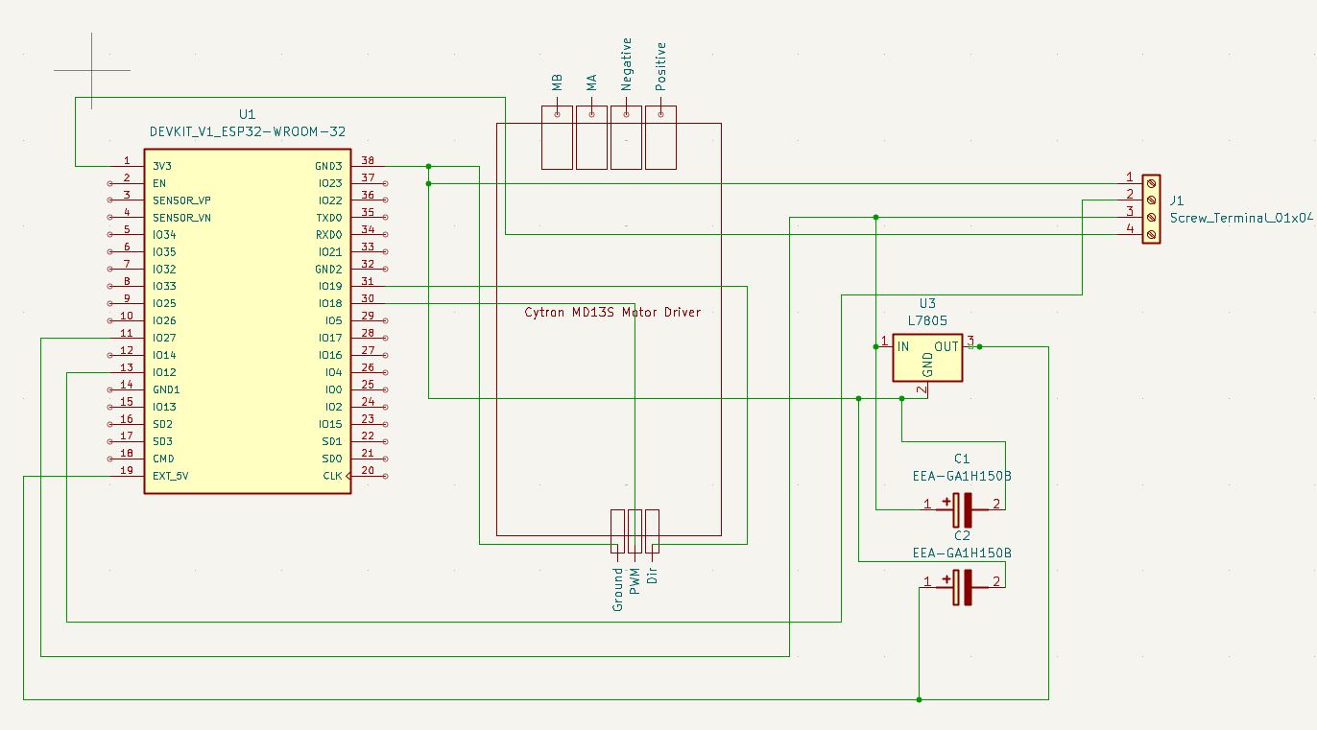

Figure E1. PCB Layout of PD Controller

With this layout we were then able to make the PCB with the traces being run in KiCad and then from this we sent the files to JLCPCB to be manufactured. In Fig. E2 we can see the PCB in KiCad with the through holes and traces being run.

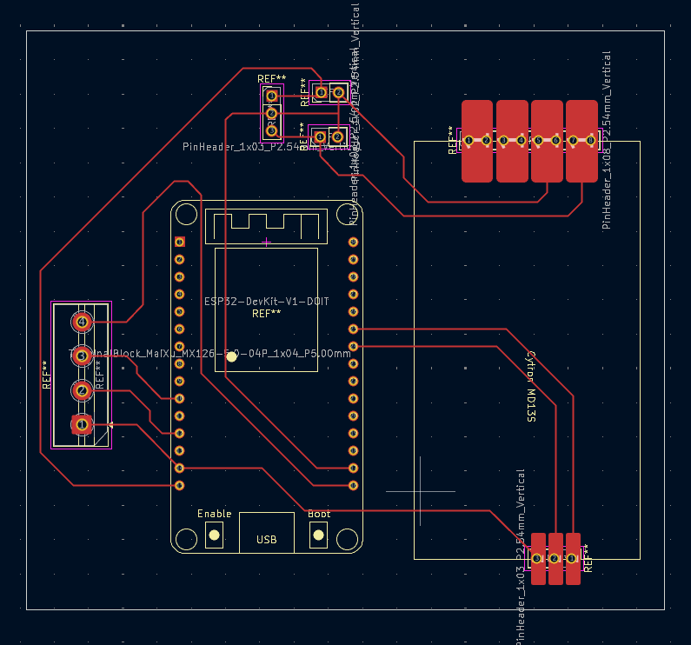

Figure E2. PCB Design in KiCad

We can see in Fig. E3 the manufactured PCB from JLCPCB, we decided to use JLCPCB as they have very short lead times and high-quality manufacturing.

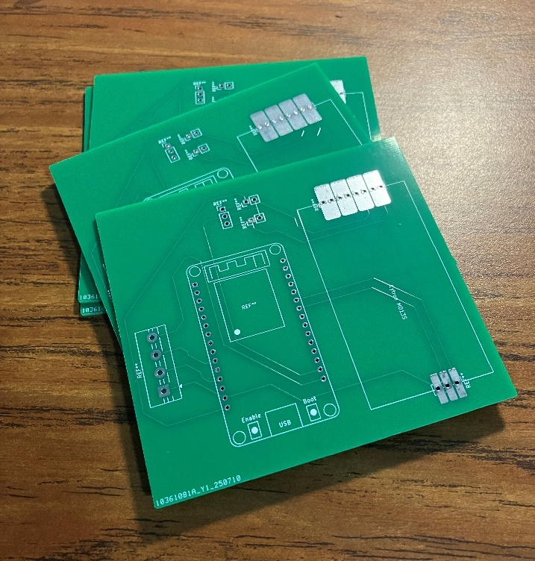

Figure E3. Manufactured PCB

With the manufactured PCB we then ordered new components for this controller to keep our protoboard together. We figured it would be best to keep the protoboard in case there were issues with the PCB we could then still tune the system while waiting for a redesign to be done.

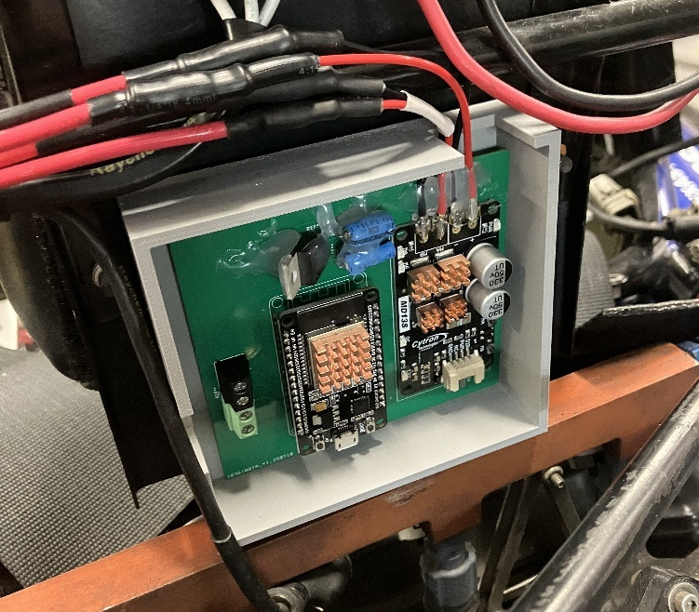

Figure E4. Complete PCB Mounted in Car

We have the complete PCB will the components mounted in the car in Fig. E4. The files are going to be provided for future work and integration to be done.

**Appendix F – Adjusting Code**

The code is posted on a [github page](https://github.com/TaydenCarter/FourWheelSteering.git) with a bunch of comments highlighting what variables are assigned to what pin on the controller or the gains associated with the controls. This was done in VSCode using ESP-IDF and utilizing FreeRTOS. The components that need to be downloaded to be utilized in your specific environment are simply just the files in the \main folder of the github repo. We specifically have this code designed for the ESP32-DevKit-V1, some of the libraries are not necessarily going to be found on the first run of this so to have them using ESP-IDF one would need to click build. When the build files are there then changes can be made to the code and successfully uploaded to the system. All the files in the \main folder are crucial for the system to run as they include the header files that the main.c code references that are characteristics of the car that were taken from Appendix A. An example of that is in Fig. F1 we can see the values taken from F16 from the testing in Appendix A and this is in the TurnRadiusCalc.h header file.

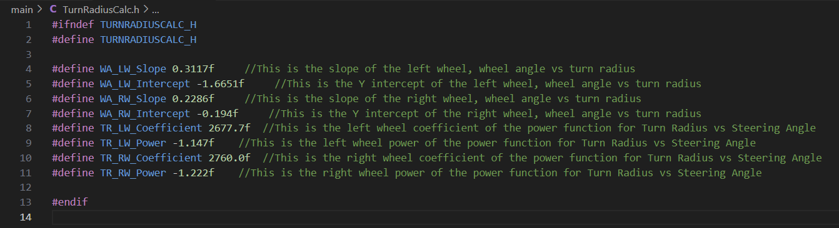

Figure F1. F16 Turn Radius Measured Turning Values

This is important for future integration to properly change them as the turn radius calculation shown in Fig. F2 is directly related to the vehicles’ specific turn radius. Also shown in Fig. F2 is Dr. Woods’ equation for the percent rear steer so if adjustments need to be made this is where they would be done. The equation for that is in Appendix B and when looking at the code all the variables are explicitly defined so adjusting the proper ones is crucial.

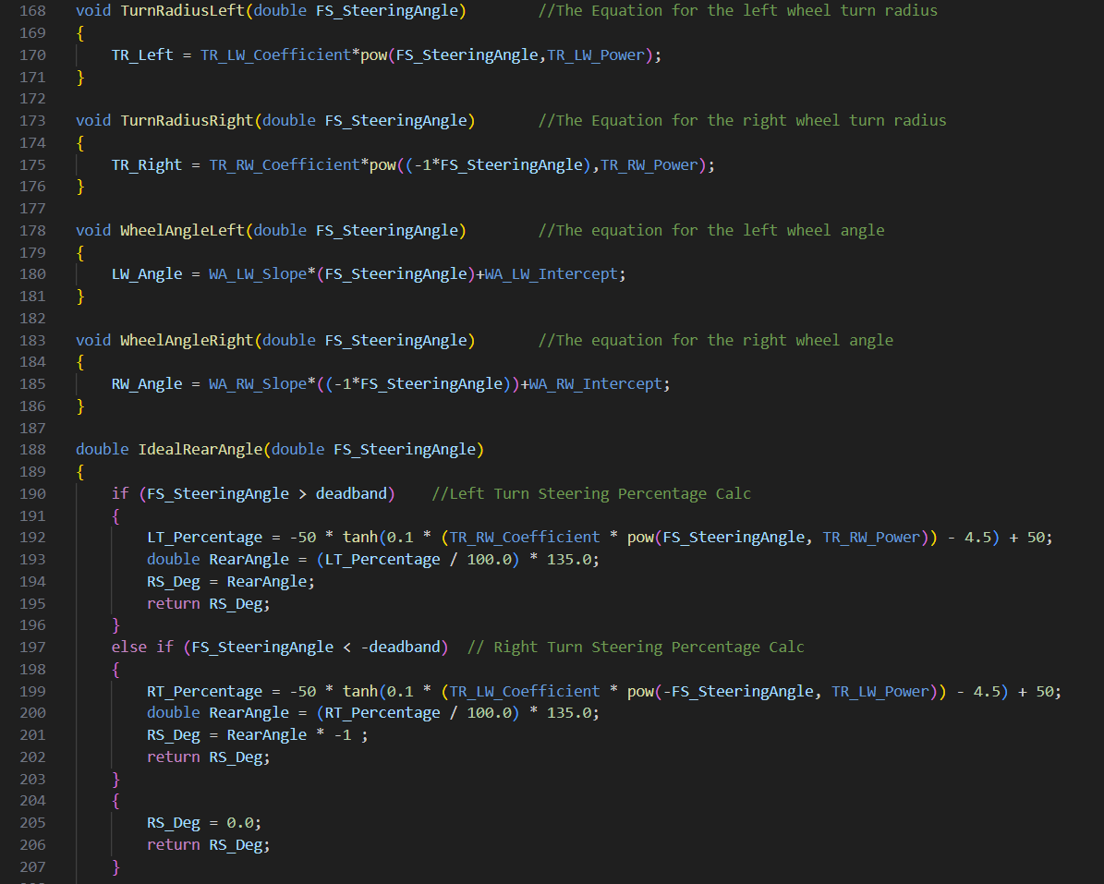

Woods Equation

Woods Equation

Figure F2. Turn Radius, Wheel Angle, and Percent Rear Steer Equations

To adjust the gain values that will be done in the main.c code and these values are static so to adjust them on the car iteratively they must be changed and then the code must be compiled and flashed onto the chip. The flashing of the code onto the chip is rather simple in ESP-IDF as is done by a “Flame” button which compiles/builds and flashes the ESP32. The gain values are shown in Fig. F3 and the values shown are the current values on the car.

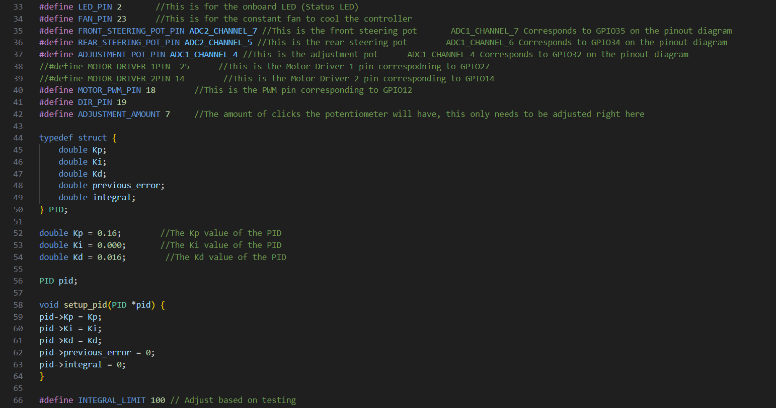

D Value

I Value

P Value

Figure F3. PID Gain Values

If one runs into issues with the pots or wants to correct the zero offset that is shown in Fig. F4 where in our case, we adjust the zero offset by simply measuring what the value is outputting to the computer when the wheel is at TDC and then subtracting or adding appropriately to make the front pot value equal to zero. The potentiometers degree values are zero at TDC then +90 when rotated CCW from TDC and -90 when rotated CW from TDC. Adjustments to the rear pot could also need to be made and if so, it is done the same way as the front pot.

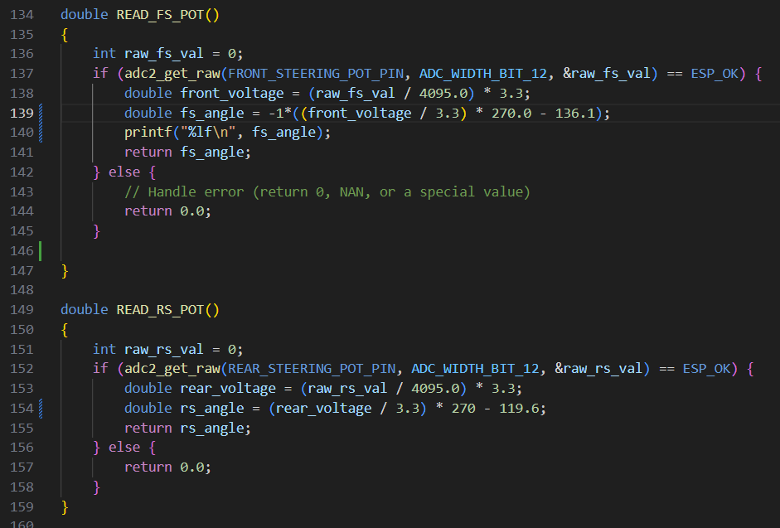

Rear Pot Zero Offset

Front Pot Zero Offset

Figure F4. Potentiometer Zero Offset Adjustment Values

There is a file header called RearAngle.h and this is setup for if the rear steering is connected to a car that doesn’t use the full displacement of the rack for the 6 degrees of rear steer. Do tests similar to Appendix A on the rear steering to obtain the values and then adjust them in the header accordingly. The variables can then be swapped in Fig. F2 in Woods equation with the front steering variables to account for the rear steering kinematics and their associated rear steering percentage . There is also a PWM.h header for the respective PWM values for the servo on the rear, if adjustments need to be made to that we can see their respective values in Fig. F5

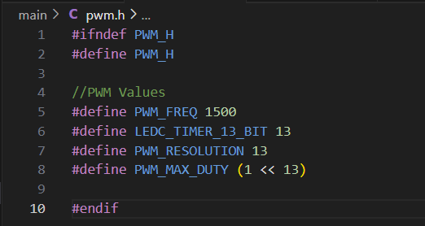

PWM Values

Figure F5. Servo PWM Values

If there are any questions regarding the tuning of the code feel free to reach out to my personal email ([tayden.j.carter@gmail.com](mailto:tayden.j.carter@gmail.com)) and the Github repo link is below

<https://github.com/TaydenCarter/FourWheelSteering.git>